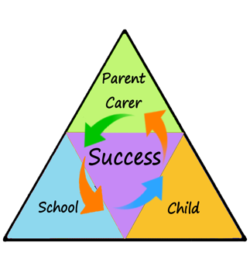

Welcome to Year 5 - we hope everybody had a fantastic summer!

This term our topic is called Power. Below is a brief overview of what learning challenges lie ahead over the coming months, as well as key information such as PE slots and homework days.

By the start of next week, your child will have been given a new reading record, reading book and home learning kit.

If you have any questions or queries, please don’t hesitate to come and speak to us.

Many thanks, Miss Halligan and Mr Regan.

[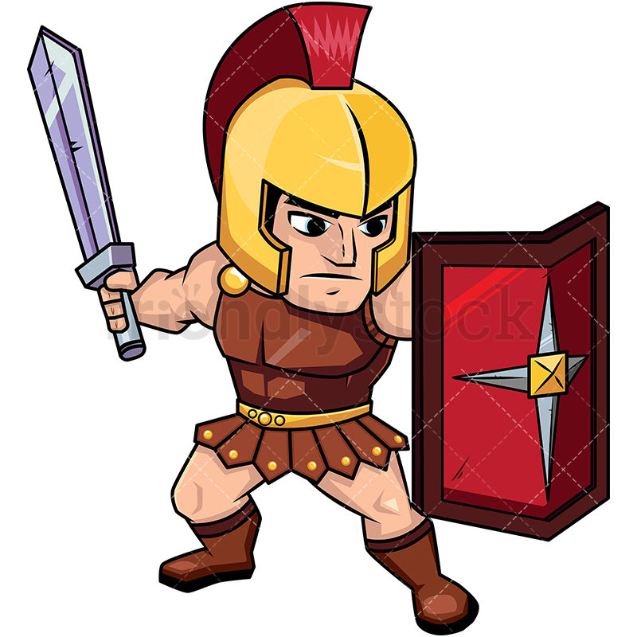](https://www.google.com/url?sa=i&rct=j&q=&esrc=s&source=images&cd=&cad=rja&uact=8&ved=2ahUKEwiO5I6Vr6bdAhVFURoKHdFqCsMQjRx6BAgBEAU&url=https://friendlystock.com/product/roman-soldier-on-guard-with-shield/&psig=AOvVaw26yE5FhHoQRCy5vHSCalTX&ust=1536322919288999)

In **PSHE**, Year 5 will be focussing on the topic New Beginnings. They will also be doing lots of work on our 7 Allanson Street Values.

**POWER**

**Romans, Anglo-Saxons & Vikings**

**Homework** is set every Thursday and is due back in the following Tuesday.

For the first term of Year 5, all children will be completing their Spelling Clubs every Tuesday. Next week, your child will come home with the spellings they need to learn based on the spelling club they are currently working at.

Pupils are expected to read at home three times a week, a reading record check will take place every Friday.

Pupils are expected to make 3 progressions each week on MathsWhizz.

In **Art** and **D&T**, children will be creating Roman mosaics and portraits of Vikings using mediums such as charcoal and chalk pastels as well as constructing longboats.

Our **PE** slot this half term is on a Monday afternoon in the school hall (indoor PE kit required).

In **Science**, pupils will be studying Space. Children will find out the answers to questions such as - What causes day and night? Why do we have seasons? How old would I be if I lived on Mars?

In **History**, Year 5 will be finding out about the Romans, Anglo-Saxons and Vikings.

In **Geography**, we will be researching where the Romans, Saxons and Vikings originated from and what Great Britain looked like pre 1066.

In **English**, we will be exploring the story of 'Bling!' as part of our Dilemma stories unit, followed by the traditional poem, 'The Highwayman'.

Our class story for the first half term will be 'How to train your Dragon' by Cressinda Cowell.

We will mostly be focusing on place value and written methods for addition and subtraction in **Maths** this half term. It is vital that Year 5 children have a rapid recall of their 2 – 12 times tables, so it would be much appreciated if you could support your child’s learning of these at home.