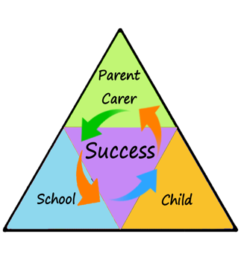

We are continuing with our Power topic this term. Below is a brief overview of what learning challenges lie ahead over the coming months, as well as key information such as PE slots and homework days.

If you have any questions or queries, please don’t hesitate to come and speak to us.

Many thanks, Miss Halligan and Mr Regan.

[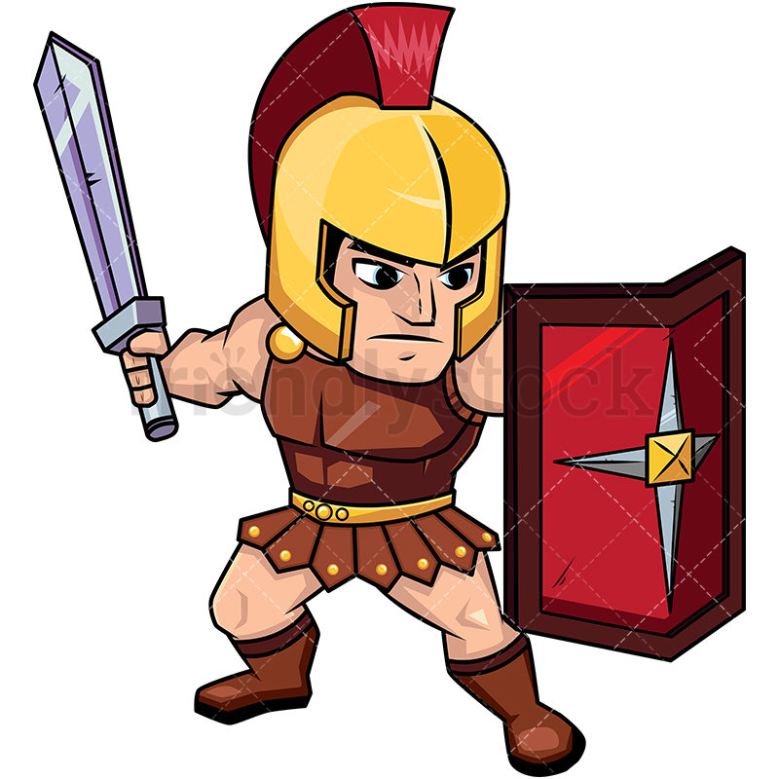](https://www.google.com/url?sa=i&rct=j&q=&esrc=s&source=images&cd=&cad=rja&uact=8&ved=2ahUKEwiO5I6Vr6bdAhVFURoKHdFqCsMQjRx6BAgBEAU&url=https://friendlystock.com/product/roman-soldier-on-guard-with-shield/&psig=AOvVaw26yE5FhHoQRCy5vHSCalTX&ust=1536322919288999)

In **PSHE**, Year 5 will be focussing on the topic ‘getting on and falling out’. They will also be doing lots of work on anti-bullying and how best to deal with situations.

In **Science**, pupils will be continuing to study Space, then moving on to exploring forces.

**POWER**

**Romans, Anglo-Saxons & Vikings**

**Homework** is set every Thursday and is due back in the following Tuesday.

For the first term of Year 5, all children will be completing a spelling test every Tuesday.

Pupils are expected to read at home three times a week, a reading record check will take place every Friday.

Pupils are expected to make 3 progressions each week on MathsWhizz.

In **Art** and **D&T**, children will be creating portraits of Vikings using mediums such as charcoal and chalk pastels as well as constructing longboats.

Our **PE** slot this half term is on a Monday afternoon with Coach Adam in the school hall (indoor PE kit required).

In **History**, Year 5 will be finding out about the Romans, Anglo-Saxons and Vikings.

In **Geography**, we will be researching where the Romans, Saxons and Vikings originated from and what Great Britain looked like pre 1066.

In **English**, we will be exploring the traditional poem of 'The Highwayman' as part of our Dilemma stories unit, having completed the story ‘Bling’ last half term.

Our class story for the first half term will be 'Cosmic’ by Frank Cottrell.

We will mostly be focusing on mental and written methods for multiplication and division in **Maths** this half term. It is vital that Year 5 children have a rapid recall of their 2 – 12 times tables, so it would be much appreciated if you could support your child’s learning of these at home.