Maths
http://www.dearzooandfriends.com/DearZoo/CardMatch/index.html
Have a go at the memory game above and then make your own set of animal pair cards- make 10 cards in total then you can play lots of different games.
https://central.espresso.co.uk/espresso/modules/news/first_news/numbers/120926n_zoo.html?source=search-all-all-all-all&source-keywords=zoo%20weigh%20in
username: student22697, password: aspass
Watch the espresso clip above to learn about how animals are weighed and measured in the zoo- then maybe you could do some measuring yourself. Pets, people, objects – you choose!

Literacy
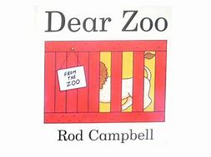
https://youtu.be/rudDGRQ9QGA
Click the link above to listen to this week’s key story, there’s also a Power point version on our class page on the website for you to try to read together.

When you’ve heard the story then write a letter to the Zoo to ask them to send you a pet. After that you can create a story map or zig zag book to show the animals they might send to you!!
Will you send them back?
Communication and Language

https://www.pobble365.com/magic-biscuits/

Have a look at this amazing image and encourage your child just to talk about what they see and what they think has happened.

Use the “Story starter” and “Question time” to extend the discussion.

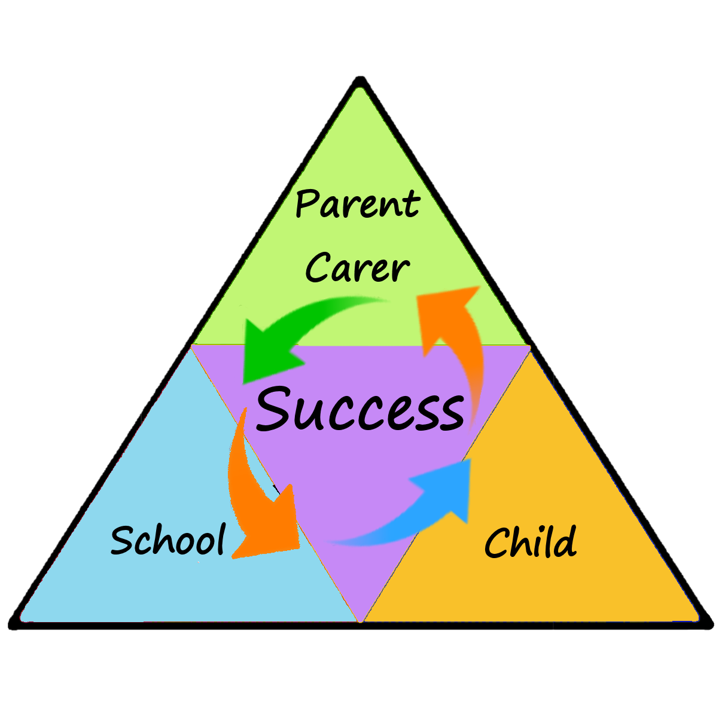
Expressive Arts and Design

Can you recognise the sounds that different animals make? Can you make animal sounds? Listen to the radio programme on the link below to find out more about animal sounds and hear a story about a Guinea Pig who lost his squeak.

https://www.bbc.co.uk/teach/school-radio/eyfs-listen-and-play-pets/zdk9382

Try singing some familiar songs but instead of words use noises- see if your family can guess the song from the tune. Upload your videos to your profiles to see if your teacher can guess too!

http://www.dearzooandfriends.com/DearZoo/NoisyFarm/index.html

Physical Development. 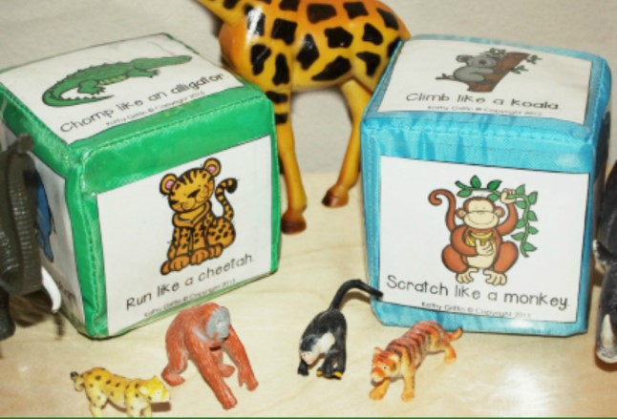 Let’s see which animals you can move like! Use a dice, make a dice or number six different animals. Ideas are on our class website on the Powerpoint. Roll the dice and move like the animal it lands on.

https://www.twinkl.co.uk/resource/t-t-16412-animal-movements-powerpoint

Nursery
Learning at Home
27-4-2020
Newsletter
Personal, Social and Emotional
Demonstrate our Value of the Week (Independence)

Watch the story on Youtube “You can do it Sam”

https://www.youtube.com/watch?v=Qc0CEm-utEs
Try to think about things that you can now do by yourself (independently) maybe draw a picture, write a list or video yourself doing these things.

Understanding the World

Click on the link below to watch a shadow version of “Dear Zoo”, look closely at the shapes that are created. Have a go at making some shadow puppet animals of your own to use indoors or out. See if you can use your hands to make the shapes of any of the animals too!
https://youtu.be/_rsw5apK_M0
As the book this week looks at the sizes of animals it links quite nicely with the whole school science challenge. Why not have a go!

“We would like you to be true scientists, and investigate: Is there a link between the length of your outstretched arms and your height?
This week, many other year groups in our school will be investigating this too, so if you have a brother or sister in school you may be able to work with them. Grown ups - please make your own judgement about whether to complete the younger or older child activity for this, dependent upon your child's writing ability.”(Mrs Calley)

