Maths
After watching the video clip about looking after pets encourage your child to look after their own pet at home over the next few weeks and record on a chart how many times they feed, clean, play or exercise their pet by using a tally or a tick.

Nursery – Twinkl - https://www.twinkl.co.uk/resource/formidable-sid-pets-peg-counting-to-10-activity-t-m-3919
Encourage your child to count the animals and then attach a clothes peg onto the correct number. Some children may need to count along with you and find the matching number. Remind the children to say one number for each animal as they move their finger to count.
Literacy
Our Starting Point – Please follow the link below to find the book that we are focussing our learning on this week. Read the story with your child and when finished ask you child to talk about what happened in the story. “What pets did the children have?”

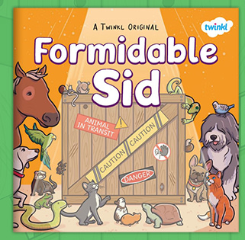https://www.twinkl.co.uk/resource/formidable-sid-ebook-t-e-1

Phonics – encourage your child to listen to the sounds in the box and choose the correct animal. https://www.phonicsplay.co.uk/AnimalBingo.html
Communication and Language
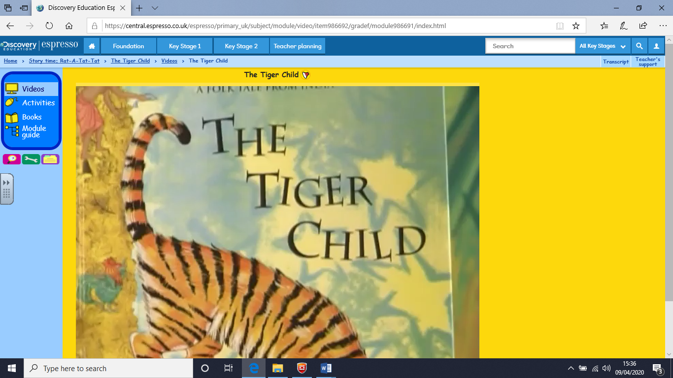 When you have watched the espresso video “The Tiger child” see if you can complete the linked activities. “Sita’s Tiger” is a story that is the reverse of this story, watch it next and talk about the differences.
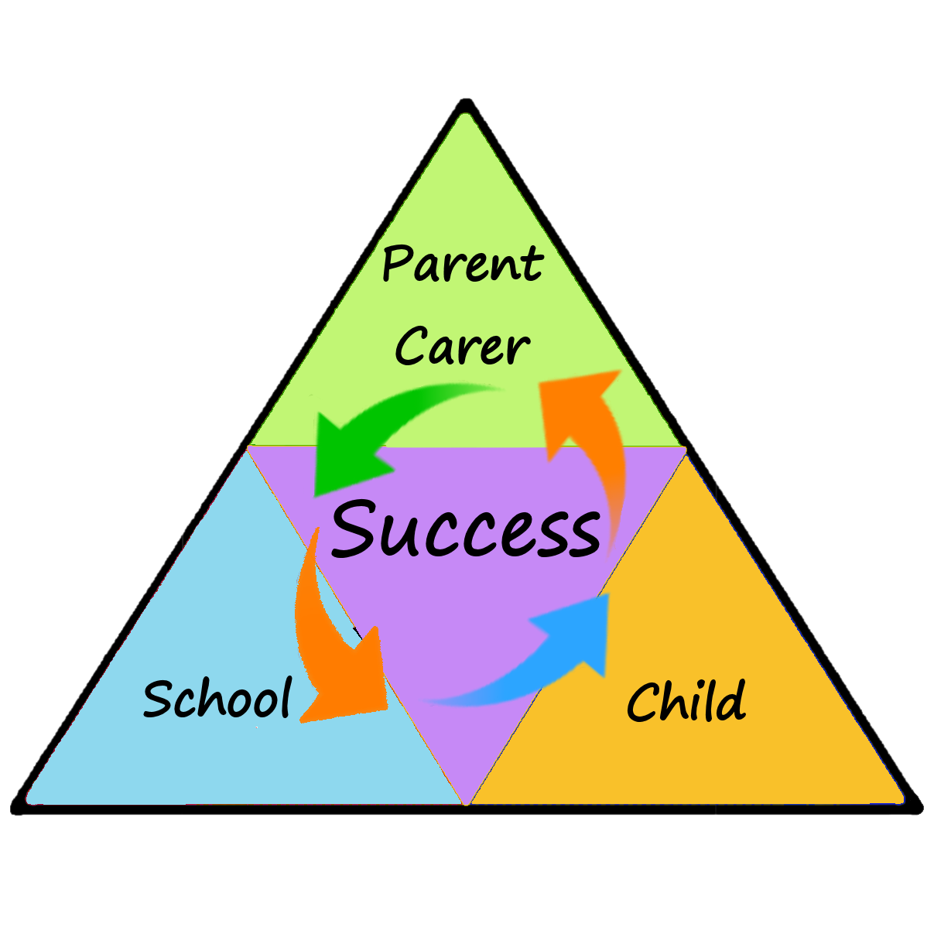
Expressive Arts and Design

Can you create your own pet? You could use a computer, paint, collage, you could draw it or use anything you have around the house! Take a picture of your pet for your Class Dojo Portfolio.

Ever wanted your own pet?! Why not a pet rock!
https://www.twinkl.co.uk/resource/formidable-sid-pet-rock-craft-instructions-t-tp-7304
Take a picture of your new pet for your Class Dojo Portfolio!

I’m sure you know lots of pet songs but there are a few new ones in the link below- happy singing!
https://www.twinkl.co.uk/resource/t-t-2546608-pets-songs-and-rhymes-powerpoints-pack

Physical Development
The children really enjoy Cosmic Yoga on YouTube. Have a look at the two ideas below.

“Mini the Puppy | Cosmic Kids Zen Den - Mindfulness for kids”

“Parsnip the Cat | A Cosmic Kids Yoga Adventure!” There are 2 episodes of this if your child really enjoys it.

Learning at
Home
Newsletter
Personal, Social and Emotional

After watching the espresso clip “Unwanted rabbits” why don’t you make a “Think about it!” poster so that more pets aren’t abandoned.

Demonstrate our Value of the Week (Kindness)
Have a look at the story – The Smartest Giant in Town https://www.youtube.com/watch?v=cfiPrA8E3qE
Kindness – How can you show kindness this week? Maybe help a grown-up with some jobs around the house.

Understanding the World

Espresso – Look at “How to look after your pets” video clip that will show you how we look after our pets. Use the questions at the side of the screen to encourage your child to think more about the topic.
(See Maths activity to follow on from this activity)

Have a look at the PowerPoint ‘All About Pets’.
https://www.twinkl.co.uk/resource/formidable-sid-all-about-pets-information-powerpoint-t-tp-7349
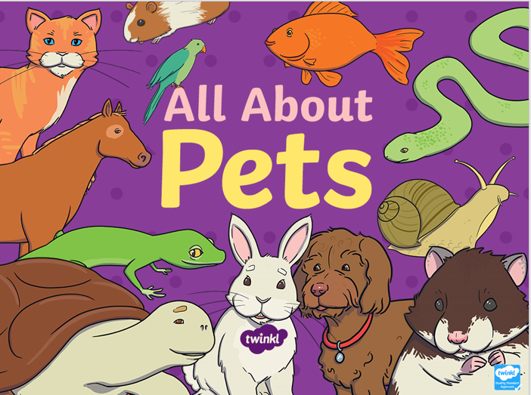 (see Expressive Arts activity to follow on)

