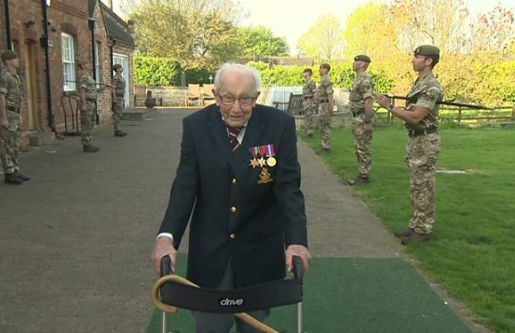

Look at this image with your child and encourage them to talk about it.
Prompts to help with discussion –
Who is it?
What did he do that was special recently?
Who are the people standing near him?
Why are they standing there?
He has something special attached to his coat, what are they? Why do you think he has them?
He completed his 100 laps by himself, do you think that he earned his medals alone? Who else would have helped him?
Just as the animals on the farm worked together to catch the robbers in our story, Tom Moore and the other soldiers worked together many years ago to protect our country.

