**English**

**Reading:** We would like you to complete the comprehension questions for the ‘Ariana Grande’ text. (This task was specifically requested for by Olivia O!)

**Writing:** We would like you to complete the fronted adverbials worksheet. You can use the fronted adverbial word bank to help you!

**Spellings:** Please practise **‘**Words starting with de-’.

Children in Miss Halligan’s English set may want to continue practising spellings from the 100 club instead.

**Maths**

We have a 10-minute lesson each day for you to complete. The tasks are linked to the lesson so please watch the lesson first and then complete the tasks.

**MON:** [**https://youtu.be/heb9RYUOugo**](https://youtu.be/heb9RYUOugo)

**TUE:** [**https://youtu.be/XhzNp4HSDdE**](https://youtu.be/XhzNp4HSDdE)

**WED:** [**https://youtu.be/9_E-iY1tpEQ**](https://youtu.be/9_E-iY1tpEQ)

**THUR:** [**https://youtu.be/EGkqai1T9AM**](https://youtu.be/EGkqai1T9AM)

**FRI:** [**https://youtu.be/mNzgtA66Tik**](https://youtu.be/mNzgtA66Tik)

**WE HAVE ALSO PUT SOME DIFFERENT WORKSHEETS ON THE WEBSITE IN CASE YOU FANCY A CHANGE FROM THESE LESSONS!**

**Science**

This week we are challenging you to make a paper spinner! Then we would like you to carry out a fair test (just like real scientists do) to investigate:

**How can you change the paper spinner to make it accurately hit a target?**

*Grown-ups – Please see the guidance for further information.*



To continue the Star Wars theme… we remember how much you love Baby Yoda!

This week, we want to see if you can follow this drawing tutorial and produce your own Baby Yoda!

“Excited we are” to see your masterpieces.

<https://www.youtube.com/watch?v=a1NT7aWr_ow>

**Get Creative**



**Our World**

We are really missing our Spanish lessons, so this week’s home learning task is to do a little bit of Spanish revision.

So far in Year 5 we have learnt: numbers to 30, colours, days, months and some basic greetings. We have linked two revision resources on our website for you to complete:

1. Writing different dates in Spanish
2. Counting the animals and writing in Spanish how many there are

**We will give extra dojos for super neat presentation – so it’s a bit of a handwriting task too!**

**Demonstrate our Value of the Week**

How can you show **resilience** this week?

You could persevere with something that you find a little bit tricky, maybe your spellings or a difficult maths task? You could try and beat your rock speed on TTRS by completing some studio sessions!

**Word of the Week**

Persevere – To use your mind or body to overcome a challenge

**Time to Move**

We missed a trick by not posting this on May the 4th… better late than never though! This week, why not try doing a Star Wars Jedi Training Workout? If you don’t own a light saber you could even make one!

<https://www.youtube.com/watch?v=6wVo6HmfIds>

Learning at Home

Year 5

WC 18/5/20 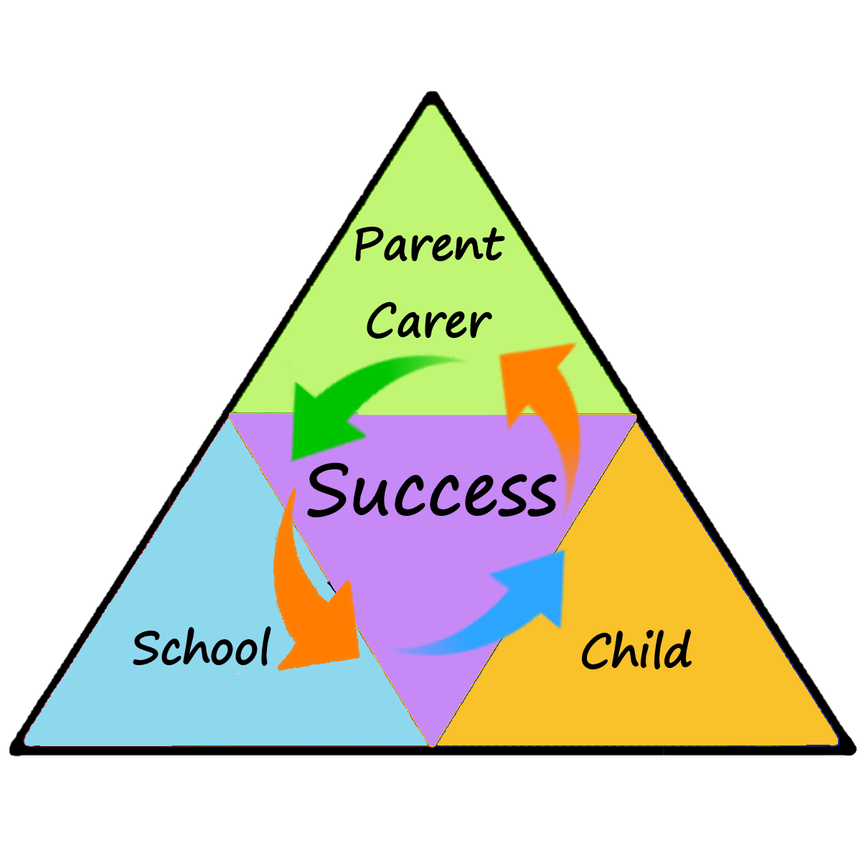

Newsletter