Summer Term Science Week 5:

Enquiry Type - Fair Test
Question
How can you change a paper spinner to make it accurately hit a target?
Firstly, make a spinner:
- Cut an A4 piece of paper into 3 equal rectangles  - Cut and fold rectangle as shown below: Fold along dotted lines, cut solid lines  - Attach a small amount of mass (weight) to the bottom of your spinner eg. paper clip or blue-tac.  - Draw a target zone on another piece of paper or place a target on the floor.  - Drop the spinner above the target and watch where it falls. | 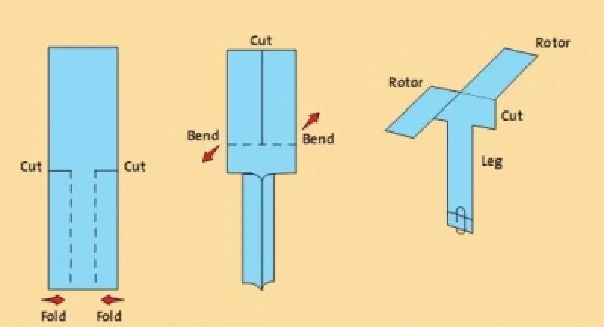
Now, carry out a fair test to explore what makes the spinner fall most accurately.
Once you have made a paper spinner, drop it from a height above the target. Does it land in the centre every time?
Try changing only one thing at a time to make the spinner fall more accurately, so that you can say exactly what improved the spinner.
Eg. The height dropped, number of wings, number of paperclips/ size of blue tac, size of paper, type of paper (use card for example).

Younger Children | Older Children
Create a poster that explains what you found out. Can you include in your poster: your equipment, what was easy and hard to carry out, your result. | Write a mini report of your investigation showing your question at the top, your prediction about what will happen (good guess) and your results.  After you have finished, analyse your results. Think about:  - Was your prediction correct?  - How could you have improved the investigation?  - What other investigations could you carry out?
Challenge | About this type of Scientific Enquiry
Imagine you are trying to advertise the spinner. Create a leaflet on how to make the best spinner making sure you use the evidence you have recorded to support your claim that it is the best type of spinner. | A fair test is when scientists look at all the different things (variables) that could affect the result.  Then they only change one of them to see if it affects the outcome. By only changing one variable, scientists are able to confidently say that that caused the result. Eg. If they changed the number of wings and the mass of the  spinner they would not know if it was the mass or the number of wings that changed their result.  Fair testing is often used to develop new medicines.

