Summer Term Science Week 3:

VE Day Special!
Question
Can we slow the speed of a parachute by changing its size?

Don’t forget to take a photo of your investigation to share with your teachers and classmates on Dojo using #hts
During World War II, paratroopers (military parachutists) would often assist the land army. They jumped from planes, pulled their parachute and would float down to the ground. It was important that their parachutes floated down at just the right speed to make sure the paratroopers were not hurt on landing.
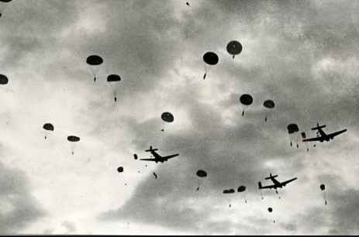

Can you design and build a parachute for your ‘paratrooper’? This could be a small figure, ideally something like a lego man, or simply a clothes peg or a small lump of playdoh.
You should try to make at least 2 parachutes, of different sizes, to see which falls fastest, or slowest, to the ground.

What you will need:
- Carrier bag, paper, material etc for your parachute
- A lego man/ clothes peg or similar
- String or something else to fasten your man to the parachute (wool, thread etc)
- Timer (on a phone will be ideal)

Method (what to do)  - Design and build your parachute. What do you need to think about? Would a larger parachute work better than a smaller parachute?  - Record the time taken for your Lego man or clothes peg on its own to drop from a height. You’ll then need to drop the parachutes from the same height with the lego man attached with string.  - Be very careful dropping the parachute if you stand somewhere high up, and if you’re the person underneath.  - Which parachute fell to the ground most quickly? Which was the slowest?  - Which parachute would be the best for your lego paratrooper? Why? | 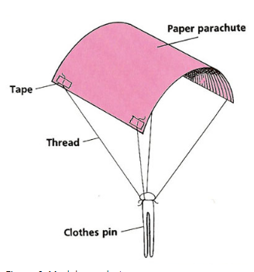

Younger Children | Older Children
Create a poster that explains what you found out. Can you include in your poster: your equipment, what was easy and hard to carry out, your result. | Write a mini report of your investigation showing your question at the top, your prediction about what will happen (good guess) and your results.  After you have finished, analyse your results. Think about:  - Was your prediction correct?  - How could you have improved the investigation?  - What other investigations could you carry out?
The Science!
If you tried dropping paper and a lego man (or similar), the paper will drop to the floor more slowly than the man. This is because the paper has a larger surface area, so has to push against more air as it drops, which means the air resistance is greater and it drops more slowly.

