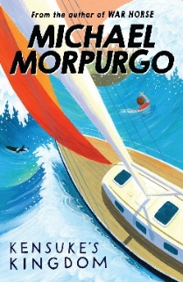
Chapter Six – Abunai!

Page 86
As the ship sailed passed the island, what did Michael vow to do?

Page 89
How long did the storm last for?

Page 91
Why did the old man warn Michael not to swim?

Page 97
What happened when Michael disobeyed the old man and went swimming?

How was Michael feeling towards the end of Chapter 6?

