**English**

**Reading:** We would like you to complete the comprehension questions for the ‘Mexican Bean Burger’ recipe – maybe you could even have a go at making the recipe!

**Writing:** Using this link, <https://www.bbc.co.uk/bitesize/articles/zn26hbk> please complete the lesson on alliteration and onomatopoeia. Watch the video clips and then have a go at activities 1, 2 and 3. We have uploaded the worksheet for activity 3 on our website.

**Spellings:** Please practise ‘Spellings containing or’.

Children in Miss Halligan’s English set may want to continue practising spellings from the 100 club instead.

**Maths**

The maths activities this week are focusing on ‘converting units of measurement’. The lessons are delivered to you by ‘Oak National Academy’, which has been formed by several teachers across the country to deliver different lessons for home learning.

<https://www.thenational.academy/online-classroom/year-5/maths#subjects>

If you enjoyed the ‘I See Reasoning’ lessons, they are available via this link. <http://www.iseemaths.com/lessons56/>

Links to the individual Oak National Academy lessons will be available on our website.

**Science**

Enquiry time!

Once again this week we are encouraging you to be real scientists and to make careful observations about shadows.

How does a shadow change over time?

See the attached sheet for more information, along with the sundial activity for a bit of an extra hands-on challenge. Have fun!

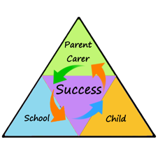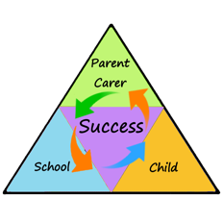

Your creative task this week is to follow the instructions and try and create this rocket! Could you be extra creative and design a background for your creation? You could even show us how much you remember from our science topic ‘space’.

**Word of the Week**

**Gratitude** - pausing to notice, appreciate and give thanks to things that we often take for granted

**Demonstrate our Value of the Week**

How can you show **integrity** this week?

Integrity is all about doing the right thing, without being asked. It can also mean being honest about your mistakes and trying your very best to learn from them!

**Get Creative**

How cool is this rocket ship made from the inside of a toilet roll?

**Our World**

Happy News! ☺

The Happy Newspaper have created a gorgeous pack that you can download from our website, it is filled with activities that focus on celebrating all that’s good in the world.

We would like you to choose a couple of the activities to complete to help spread a little happiness on our Dojo page!

There are some happy stories and facts that you can share with others, an activity for you to research and record your own happy news story, a couple of tasks which focus on showing gratitude, and even some little drawings to colour too!

**You don’t need to print the activities out, you can just copy them out into your work book!**

**Time to Move**

We know how good you already are at keeping active, but if you fancy something different this week, why not try some Minecraft yoga?

<https://www.youtube.com/watch?v=02E1468SdHg>

Join Jaime in Minecraft world and use yoga to survive your first 24 hours!

Learning at Home

Year 5

WC 1/6/20 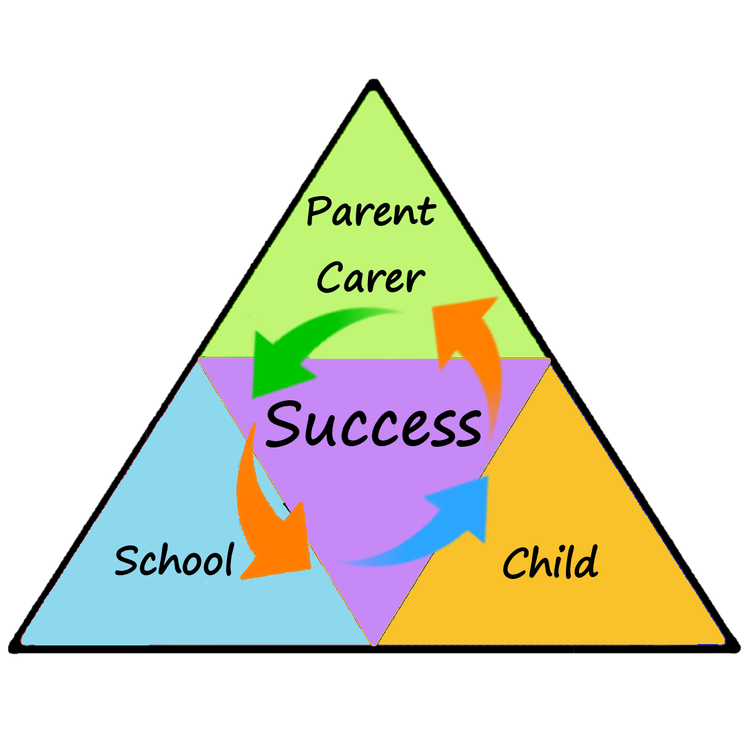

Newsletter