Summer Term Science

Enquiry Type - Identifying and Classifying
Question
Can you identify birds in your garden or on a local walk?
- We have another nature inspired science enquiry for you this week! This time, we would like you to be bird spotters! Settle yourself down by a window overlooking a garden, or with an adult, go for a walk in a local green space or park.
- Use our bird spotting guides (two different ones included) to try and identify any birds that you see.
- Look at the size, colours and distinctive features (such as beaks and tails) of the birds to help you identify them.
- Top tip! Try to keep as quiet and still as possible when you are close to birds – you may get a better look at them before they fly away!

Activity
Use the bird spotting guides to identify the birds. Do you notice any similarities or differences between different birds? Think about their size, colours and the shape of distinctive features such as their beaks. If you are lucky enough you may even hear them sing!

Extension:
Keep a tally of the amount of each bird that you see. Which are the most common?
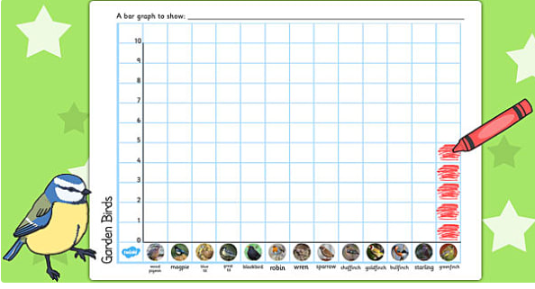
Can you create a bar graph or a pictogram to show your results, like this one below? You may want to have a go of this on the template attached, or make your own.

Challenge  If you completed this activity twice – in the same place but at different times of the day (such as in the morning and late afternoon), would your results differ?  If you completed this activity in two different places (such as your garden and the park) would your results differ? | About this type of Scientific Enquiry  Identifying and classifying is how we can make sense and order of the world around us. This enquiry type requires using observation and reasoning skills.  Examples of classifying include how we classify animals (into mammals, reptiles etc), plants and foods.  Identifying and classifying is used by scientists to help learn about the natural world.

