Term: Summer 2 Week: Monday 29th June | Mrs McLoughlin’s Literacy Group Spelling patterns – contractions

LOOK | SAY | COVER | MONDAY  WRITE | CHECK | TUESDAY  WRITE | CHECK | WEDNESDAY  WRITE | CHECK | THURSDAY  WRITE | CHECK
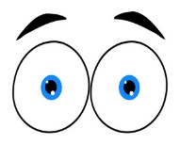 |  | 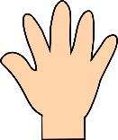
1. you’re
2. you’ve
3. they’ve
4. should’ve
5. haven’t
6. isn’t
7. don’t
8. won’t
9. doesn’t
10. wasn’t
11. wouldn’t
12. we’ll

FRIDAY – Use both of these words to create your own sentence that makes sense and is punctuated correctly:
we’ll

don’t

Term: Summer 2 Week: Monday 29th June |  | Mrs Boydell’s Literacy Group Spelling patterns – words ending in ‘y’ words with wh / ph  - adding the prefix ‘un’

LOOK | SAY | COVER | MONDAY  WRITE | CHECK | TUESDAY  WRITE | CHECK | WEDNESDAY  WRITE | CHECK | THURSDAY  WRITE | CHECK
1. very
2. happy
3. when
4. where
5. which
6. white
7. dolphin
8. elephant
9. alphabet
10. unkind
11. unhappy
12. unfair

FRIDAY – Use both of these words to create your own sentence that makes sense and is punctuated correctly:
happy

when

