Summer Term Science:

Enquiry Types - Observation over Time and a Fair Test!
Question
What happens to the ice over time?
This investigation calls on two types of scientific enquiry. We are observing over time what happens to each ice cube. We are also conducting a fair test as we are changing one thing in each bowl – the thing that accompanies the ice (water, sugar or salt) to see if this affects how long the ice takes to melt.
- You will need 4 containers or bowls.  - As in the picture, place one of the following in each bowl:  - Ice in water  - Ice coated in sugar  - Ice coated in salt  - Just ice  - Set up a timer (or use the timer on a phone!) and check your ice cubes every ten minutes to see what is happening to them.  - Don’t leave your investigation unattended, especially if you have a pet or younger children in the house.  - Which ice cubes are melting the fastest? | 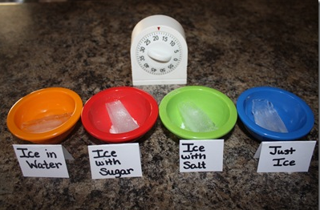

Younger Children | Older Children
Create a poster that explains what you found out. Can you include in your poster: your equipment, what you think might happen and your results. | Write a mini report of your investigation showing your question at the top, your prediction about what will happen (good guess) and your results.  After you have finished, analyse your results. Think about:  - Was your prediction correct?  - Why do you think this happened? Can you research the effects of sugar and salt on ice?

Learning Extension
Enjoyed this ice activity? Perhaps you could have a go at these!
