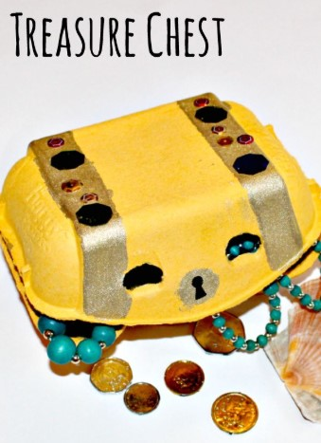

Have a go at making a treasure chest from an egg box and fil lit with things that are treasure to you. Talk about why they are special and precious to you.

