Maths
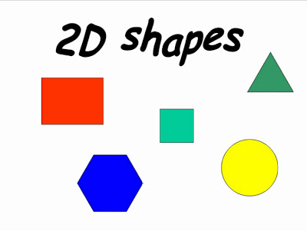
Take a look at the pirate picture on the website and find the shapes.
Why not see what shapes you can find in your house as you do a Pirate shape hunt of your own?

Count the shapes that you find. How many rectangle shapes could you find?
Record the shapes that you find by drawing or an adult writing them down. (see record sheet on website)

Literacy
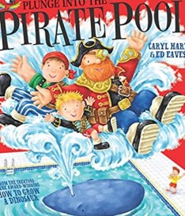This week’s story “Plunge into the Pirate Pool” sees Albie meeting a gang of pirates. Jump into our story -https://www.youtube.com/watch?v=S1OYbmmtvsE
What would you need to be a pirate?

Draw yourself as a pirate adding all the things you would need- eye patch, sword, hat etc.

Create your own message to go in a bottle. Maybe you could write a message or draw a picture for a member of your family that you haven’t been able to see recently?

There is a suggested writing frame to help you on the website or design your own.
Communication and Language

Pirates love treasure, usually gold, jewellery and valuable items. The octopus in the story was protecting her own treasures - her babies. Treasure also means something special or important to you.
Have a look around your house for things that you treasure – photos, shell or pebble that reminds you of a holiday, gift from someone special. You could make a “treasure chest” from an egg box to keep them in. (See idea on website)
Talk to your grown up about why they are a treasure to you.

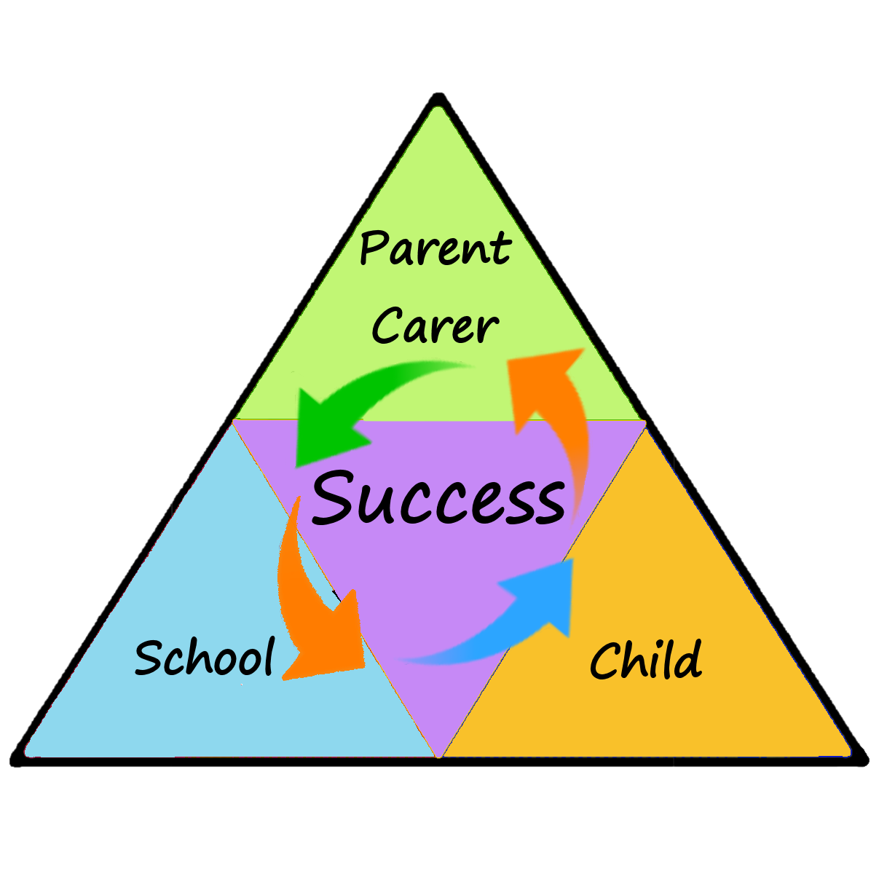
Expressive Arts and Design
Ever fancied turning into a Pirate?! Now is your chance!
Have a go at creating your own;
Pirate Hat
https://www.twinkl.co.uk/resource/t-t-16878-paper-pirate-hat
Sword https://www.youtube.com/watch?v=8HLx7KeZHks

Don’t forget to upload to your portfolios! I can’t wait to see your Pirate selfies!

Physical Development

Let’s be a pirate, jump on board with Boogie Beebies!
https://www.youtube.com/watch?v=8Q0diKmWtUE
Early Years
Learning at Home
1-6-2020
Newsletter
Personal, Social and Emotional
Demonstrate our Value of the Week (Integrity)
Look at the picture (on the website) showing the pirates taking the treasure!
Would it be right for the pirates to take it? Would it be an honest thing to do?
If you found something that didn’t belong to you, what would you do?
Understanding the World

The pirates in the story found the Treasure under the water. Think about what you would see if you were under the sea. Watch some of the video clips and look at some of the pictures to find out what you might see.
http://10.81.84.100/espresso/primary_uk/subject/module/frontscreen/item1045246/gradef/index.html?source=search-all-all-all-all&source-keywords=under%20the%20sea

Draw a picture showing what you would see below the water and above the water.

This week’s whole school Science challenge looks like a lot of fun!
How does a shadow change over time?
You will find further guidance on this week’s whole school science task in our news page of the website

