Maths – Arithmetic Time
In Year 2 you have explored all 4 calculations – addition, subtraction, multiplication and division. To help you keep revising this knowledge we have set some daily arithmetic challenges for you to have a go at!

Look through the PowerPoint to remind you how to use your fingers and recording methods to solve each type of calculation if you need a little reminder.

Log in to Espresso and play some of the games to help you develop your arithmetic skills too https://www.discoveryeducation.co.uk/
Username – student22697 password – aspass
Key Stage 1 – Maths - Please look at the addition and subtraction activities and the Multiplication and division activities.

Please keep going with your online maths activities as much as you can too:
Maths Whizz, Numbots and TTRS

English – Seaside Postcard
While we’re thinking about holidays by the sea this week (we wish!) what would you do if you were there?
Your task this week is to write a postcard from the seaside! Can you decide which resort you’d like to virtually visit?

Look through the PowerPoint to help you understand which information should be included then have a go. You can use one of the templates provided or make your own.

For an extra challenge see if you can combine your learning-use some of the nouns you’ll learn about in your our world work and combine them with interesting adjectives to describe what the place you’re writing about is like.

Spellings practice and activities
Please see the attached sheets for some new spelling patterns to learn and practise.
There are 2 sheets - one for Mrs Boydell’s Literacy group and one for Mrs McLoughlin’s.

Science – Enquiry Time
Seeing as our leaf detective activity proved quite popular a few weeks ago, we now have another nature inspired challenge!

Can you identify birds in your garden or on a local walk?

Use our handy bird spotting guide to help you!
See our guidance sheet for more information.

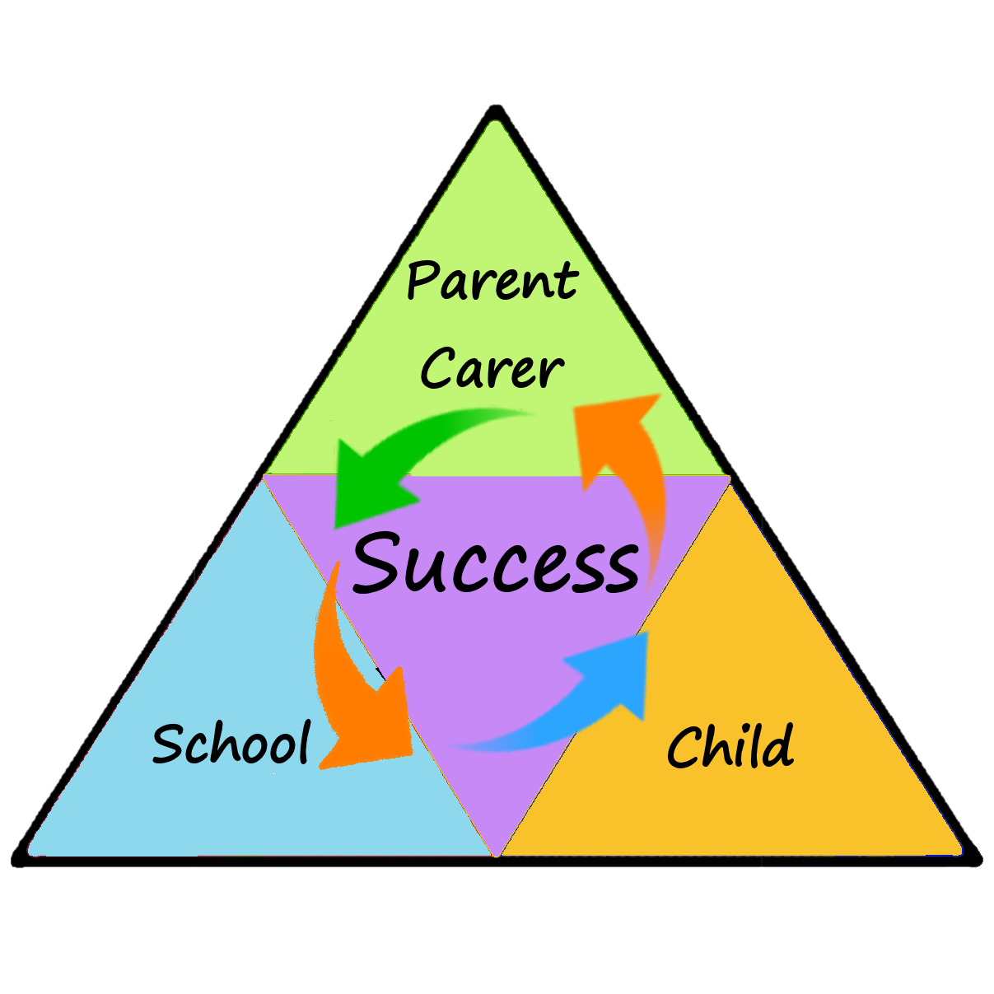
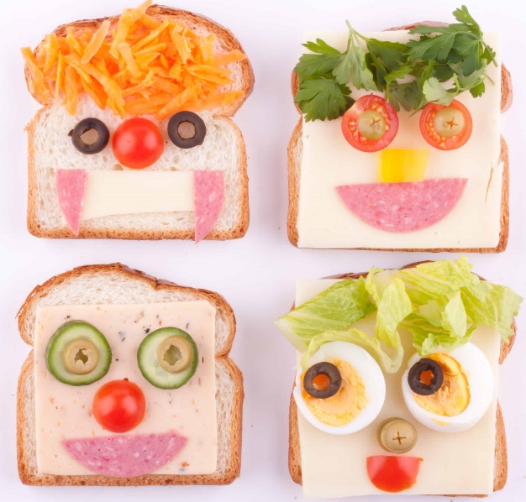
Demonstrate our Value of the Week
Resilience-how can we show resilience with our learning?

We know home learning is getting trickier by the week, so, we’d like you to have a chat about how you can keep on trying. Maybe just choose one thing to focus on each week or spend 15 minutes each day or challenge yourself to try something different like a craft or physical activity.

Get Creative – Time for an ice-cream!
When we think about the seaside we’re sure you also think about having an ice-cream too! For this week’s creative task have a go at designing your own ice-cream, making it out of paper and maybe even making your own real ice-cream to enjoy!


Time to Move
If you love Moana you’ll enjoy this cosmic kids yoga session:
https://www.youtube.com/watch?v=5y3gCrL_XIM

Try out this week’s Alphabet Fitness challenge – can you complete the exercises for your own name, then the names of other people in your family (please change the letter ‘M’ to 3 rolls!).
For extra dojos have a go at making up your own alphabet fitness challenge on our recording sheet for your friends and family to try!

Learning at Home
Year 2
WC 29.6.2020
Newsletter
Word of the Week -
Promenade-a paved public walk, typically one along the seafront at a resort.

Our World
Seaside holidays in the past
You know that the physical features of our seaside resorts haven’t changed but have the human ones?
This week we’ll be learning about how seaside holidays have changed over the past century. Have a look through the powerpoints /the lovely Magic Grandad video clips and then the fact files for some extra information.
Can you complete the table comparing past and present day holidays using photos or drawing/labelling your own? What is your favourite seaside activity?

