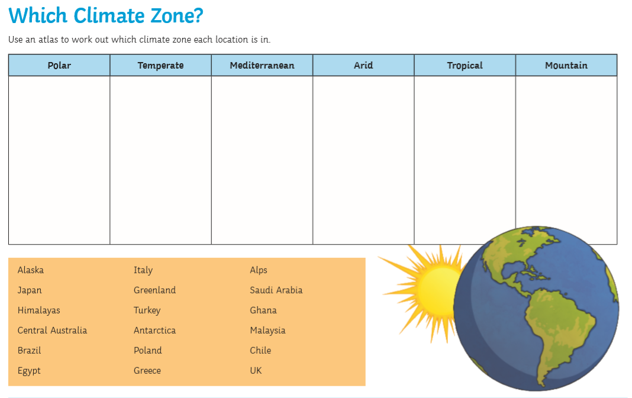

Use the world map on the last slide of the powerpoint presentation and the climate map on slide 4 to help you

place the countries below under the correct heading.

Use the map on slide 4 to help you