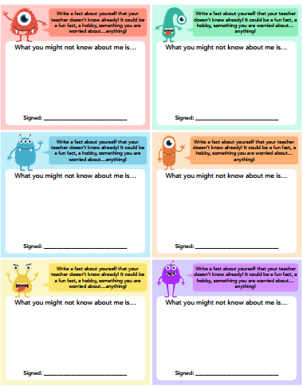
Knowing Me, Knowing You cards

