The Colour Monster
Listen to the story of The Colour Monster
https://www.youtube.com/watch?time_continue=4&v=Ih0iu80u04Y&feature=emb_title
Here is your very own colour monster. Colour him in with the emotions you are feeling about coming to year 2 in September. Think about how much of each colour you need. If you are very happy, then you will need to use lots of yellow. If you are a little bit scared, you will need to use a little bit of black.

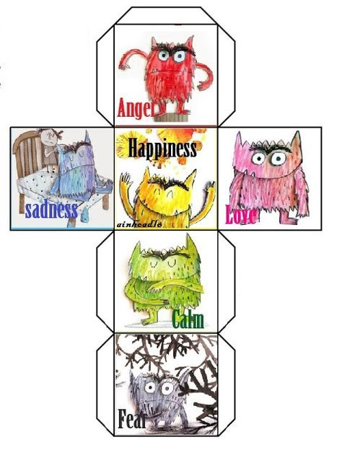

Use this image to help you remember what colour each emotion is.

Can you tell us why you feel this way? If you are scared or feeling sad, why not ask us a question to see if we can help?
Why not make your very own colour monster cube? You could use it to help show how you are feeling when different things happen.

