|  |  |  |  |
| --- | --- | --- | --- |
| Guess Who?  Draw your silhouette and colour either the background or silhouette black. Fill in the white space with facts and drawings all about you. We will be posting these throughout the day to let your class mates guess who you are?  #H2S  All about me silhouette. | Elementary art, 4th grade art, School ... | Draw with Rob        Rob is an artist who has been uploading videos on how to draw during lockdown. If you’ve not checked them out yet, they are a great way to spend half an hour!  We would love you to have a go at Rob’s self-portrait video. Draw yourself in his style. We would like you to bring these back into school in September so we can proudly display them in our Lower Junior corridor.  Video Link:  <http://www.robbiddulph.com/draw-with-rob> | Tell us more about you?  Hello and welcome to Y4! We cannot wait to see/meet you in person next year but for now we will have to meet virtually. Below are some activities which we will be posting about throughout the day. We would love it if you could share them on your portfolio #H2S.  It would be great if you could save your artwork and return it in September so we can proudly display them in our Lower Junior Corridor.  Choose as many activities below as you would like. If you have any questions or worries do not hesitate to contact us! ***Miss Knowles and Mrs McLoughlin***  Using your name can you tell us more about yourself or use the Tree Template below?    What are your hobbies?  Favourite foods?  What’s your favourite lesson?  Do you have any siblings?     *(Resources found below)* | See the source imageSee the source image  Matilda  This is the first novel we will all read together. Many of the characters face significant challenges like Bruce Bogtrotter in this extract who is challenged to…well you’ll read for yourselves!  Can you reflect on some of the challenges you might face when we come back to school and how you might tackle them. To help we have given you some ideas of ‘typical’ challenges to order from most to least difficult to overcome. There are also some blank boxes for you to cut out and write in/discuss any challenges personal to you. There are no right answers for this, we will all find different things harder. Just see what you think. |

  
**Creative Homework**  
We have attached below a creative homework based on our Autumn project: Mayans.  
If you choose, this project can be completed over summer. We can’t wait to see your creations.

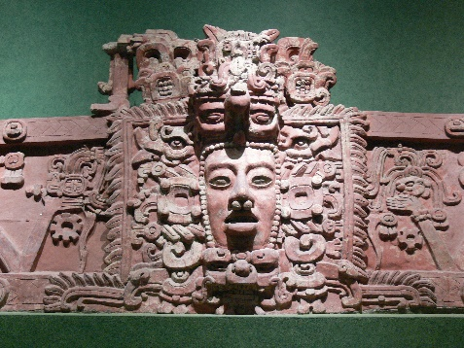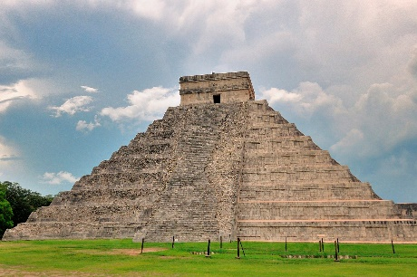**Creative Homework**

**Dear Parents of Year 4EK and 4MM,**  
We are asking the children, as part of their transition, to be creative over the summer holidays and create something linked to their first school project of Y4: Ancient Mayan Civilization. Here are some ideas below. You can choose as many as you like and even think of your own creative ideas to display in class.  
**Miss Knowles and Mrs McLoughlin**

|  |  |  |  |
| --- | --- | --- | --- |
| 1. Research what Mayan temples looked like. 11 Mayan Temples That Will Transport You Back In Time Can you make a model? Or draw them? | 1. Research what Ancient Mayan homes looked like, then show us in pictures, words or a model.   <https://everythingplayadelcarmen.com/mayan-houses/> | 1. What games did Mayans play?   Can you have a go at playing yourself?   Why not record yourself and upload it to Class Dojo… <https://www.bbc.co.uk/bitesize/topics/zq6svcw/articles/zbqyy4j> | 1. Create a word search or crossword about the Mayans. Use your sticky knowledge and research facts. |
| 1. Make a simple game about Mayans e.g. snap, Uno, snakes and ladders etc. | 1. Create a fact file about Mayans   Think about how did Mayans live? Why was farming so important to them? What did the Mayans believe in?  <https://www.bbc.co.uk/bitesize/topics/zq6svcw> | 1. What did Mayan art look like? Mayan Art of the Tattoo - History  Can you paint a picture?   Make a clay/ salt dough model?  Can you sketch the intricate designs? | Children can research at home or use the attached resources to help them create a model, fact file, poem, etc. Please keep in a safe place and we will look forward to sharing your creations in September!  Useful Websites: <https://www.twinkl.co.uk/blog/twinkl-homework-help-the-maya-civilisation> |

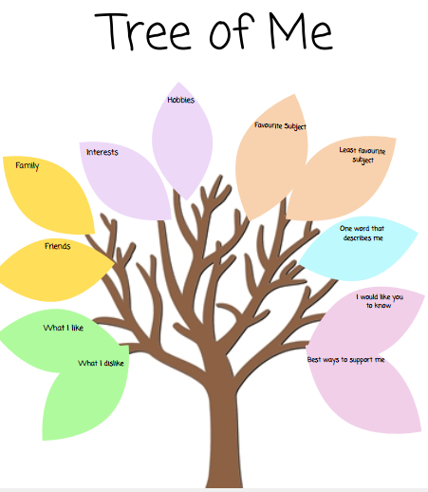  
  
Draw or print the temple above to tell us more about you!  
  
  
  
  
  
  
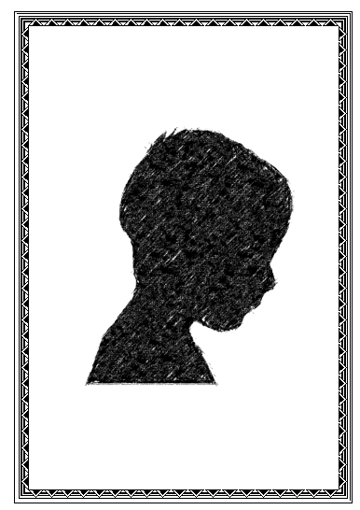  
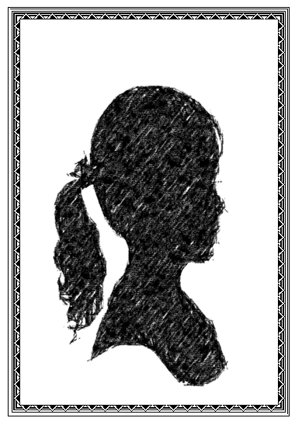  
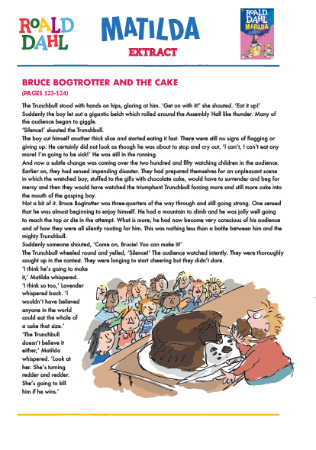

Organising my school things.

Getting up early again. Organising my school things.

Concentrating for a longer time. Not playing on my tablet/

games console as much.

Having a new/different teacher. Managing social distancing. Talking to friends I haven’t seen  
for a while

Difficult to overcome Less difficult to overcome