Hello and welcome to Y5!
We cannot wait to meet you in person next year but for now we will have to meet virtually. Below are some activities which we will be posting about throughout the day. We would love it if you could share them on your portfolio #H2S.
It would be great if you could save your artwork and project work and return it in September so we can proudly display them in our Upper Junior Corridor. Choose as many activities below as you would like. If you have any questions or worries do not hesitate to contact us!
Mrs Onyett and Mr Regan
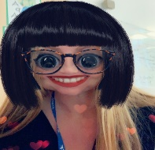  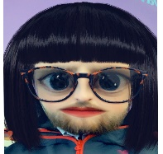  Guess Who?  Send a selfie in a disguise and get your classmates to guess who has sent it in!  Mr. Regan would love to get to know you all better as Mrs. Onyett knows a lot about you already. However, can you tell us both something we won’t already know by completing this tree?  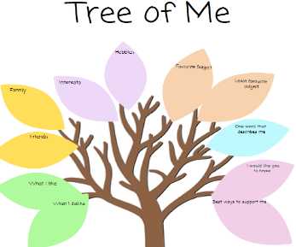 | 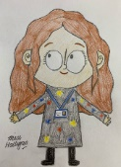  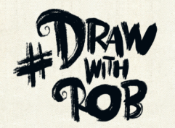  Draw with Rob  Rob is an artist who has been uploading videos on how to draw during lockdown. If you’ve not checked them out yet, they are a great way to spend half an hour!  We would love you to have a go at Rob’s self-portrait video. Draw yourself in his style. We would like you to bring these back into school in September so we can proudly display them in our Upper Junior corridor.  Video Link:  http://www.robbiddulph.com/draw-with-rob  Earth and space creative project  See resources below | Kahoot! Quiz  What is your new teacher’s favourite hobby? What is their favourite food? What football team do they support? Do they have any pets?  Test out your teacher knowledge and get to know different information about them by completing this Kahoot! quiz.  Who knows their new teacher the most?!  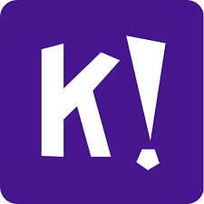  Keep an eye on ClassDojo for the game PIN and link!  Create a Crossword  Now you know all of our secrets, we want you to make a crossword of all the information you have gathered on us! | Rock Battle  Due to lock down we never got to complete our end of year times table assessment however it is still important to know ALL of your timetables up to 12 X 12.  We have added a battle on Times Tables Rock Stars  ‘Y5NO Vs Y5AR‘  We will add Dojos onto the children who have taken part and 2 dojos for the winning class.  Let the battle begin!

Creative Summer Project
Dear Parents of Year 5AR and Y5NO,
We are asking the children, as part of their transition to be creative over the summer holidays and create something linked to their first school project of Year 5: Earth and Space.
Here are some ideas below. You can choose as many as you like and even think of your own creative ideas to display in class!
- Make a 3D model rocket.  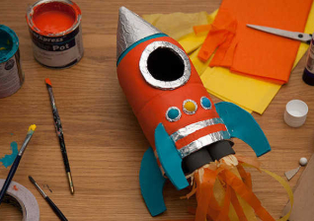 | - Create your own papier mache 3D planet from our solar system. You can also use the following link; https://www.youtube.com/watch?v=M7iokGsaYus  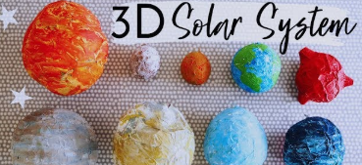 | - Create a word search or crossword about the Space. What facts have you found?  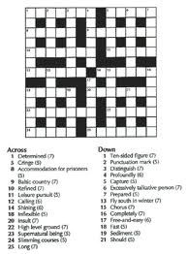 | 4. Make an acrostic for one of the planets  e.g. M  A  R  S  This could be a list of words beginning with each letter, a sentence for each line or even a rhyme.
5. Bake your own space themed cookies or biscuits. They could be star, rocket or planet shaped. They could even include space rocks such as popping candy! Write the recipe in your home learning book. Feel free to share your biscuits with your teacher in September!! | - Create a fact file about Space.  Think about the different planets in the solar system. Who was the first man on the moon? In space?  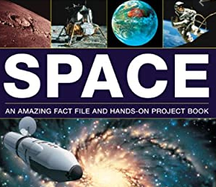  Link: https://www.bbc.co.uk/bitesize/topics/zdrrd2p | 7. Keep a sky at night journal for a whole week. Write about everything you can see in the sky. You could draw a picture of the moon every night. Does it change over the course of the week?  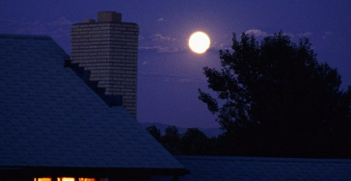 | Children can research at home or use the attached resources to help them create a model planet, fact file, poem etc. Please keep in a safe place and we will look forward to sharing your creations when we are back in September. You can upload pictures to class Dojo too ready for us to share in September.  Thank you for your continuous support, Mrs Onyett and Mr Regan.

