Year 3 Summer activities!
We would love you to get a bit crafty over the summer, and bring your creation into school with you in September. We hope to make a lovely display in our Lower Junior corridor full of your artwork!
So, pick one (or more!) of the following to have a go at:
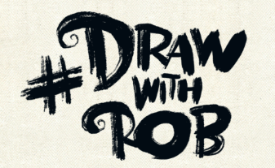  Rob is an artist who has been uploading videos on how to draw during lockdown. If you’ve not checked them out yet, they are a great way to spend half an hour!  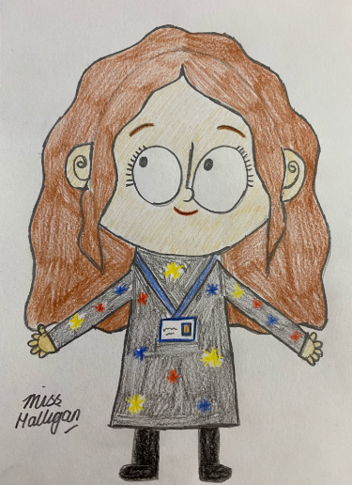  We would love you to have a go at Rob’s self-portrait video. Draw yourself in his style, like Miss Halligan’s here!  http://www.robbiddulph.com/draw-with-rob | Or maybe you could create some art using the letters in your name, or your initial, like these below:  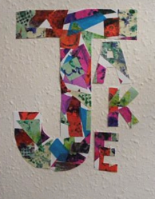  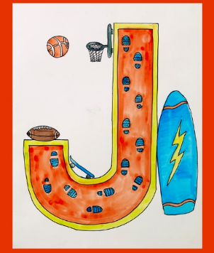  You could use any materials that you have at home, or just coloured pencils!
‘All about me’  Use the sample sheet attached for ideas to create your own poster, all about you! You could include things like your favourite books, TV programmes, hobbies, food, colour or school subjects! | Summer (or lockdown) memories  When we come back to school, we will have lots of news to catch up on! We would love to see some of the things you have done over the summer holidays, or during Lockdown in general! Please could you bring some photos into school on the first day back, or drawings, of things that you would like to tell the rest of your class about.

