After the holidays, you will be moving up to Year 5.
How exciting!

STAFF
Below are the staff in Year 5.
Any one of them will help you when you need it.

It is our job to help you to be happy, confident young people and we will do anything we can to help you to achieve this.

CLASSROOMS
We love making your classrooms bright and exciting places for you to learn in.

This is Mr Regan’s classroom.

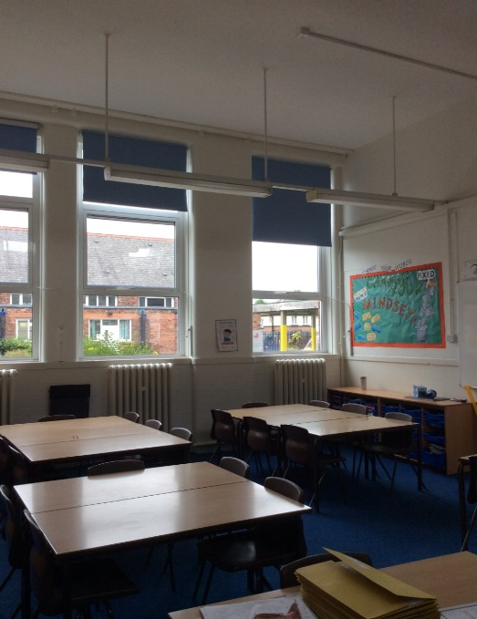

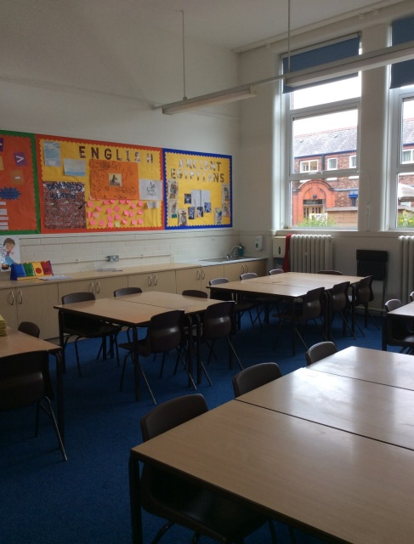
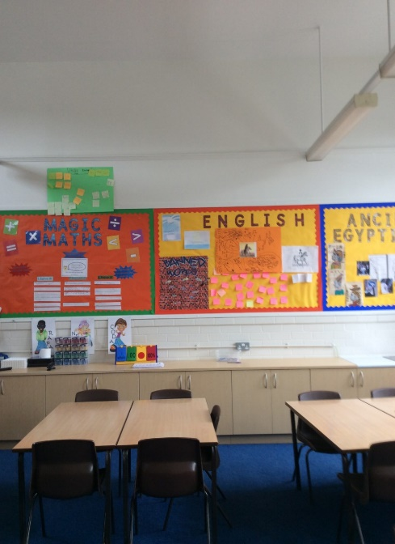

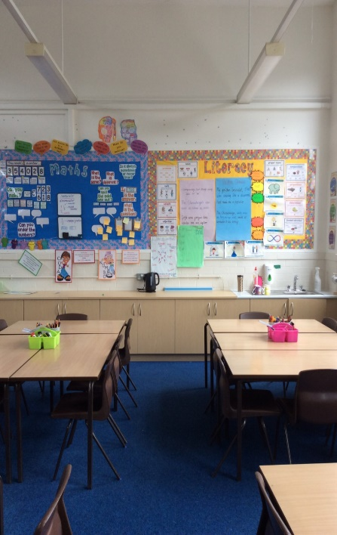
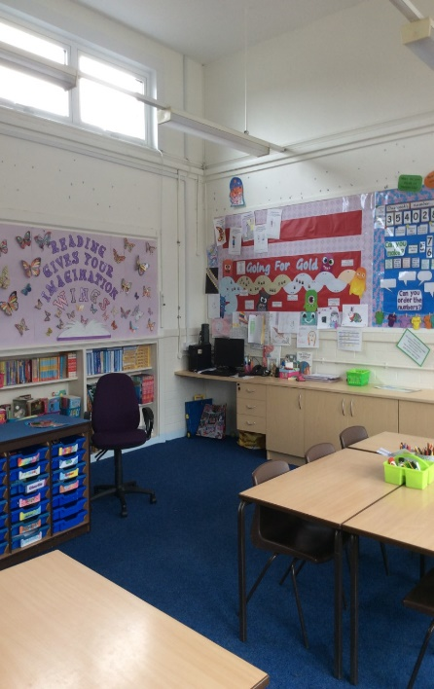
This is Mrs Onyett’s classroom.
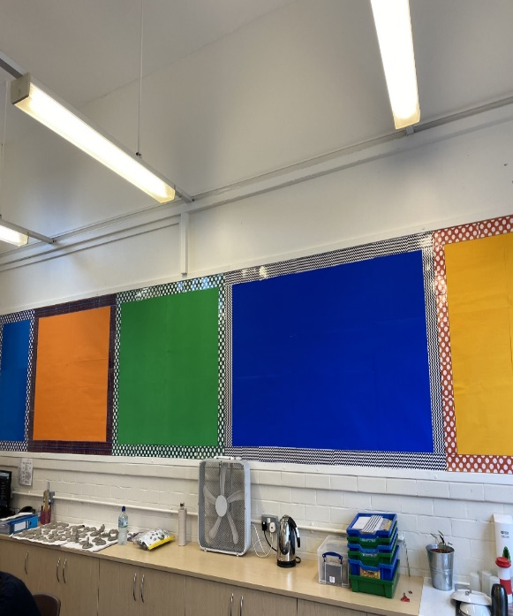

LEARNING
Throughout Year 5, in all of our subjects, you will learn some incredible things. Here is some information about our topics.

Eureka!
In this topic we learn about the wonderful culture and history of Greece! We will be learning all about Ancient Greece, especially their myths and legends!

Treasure
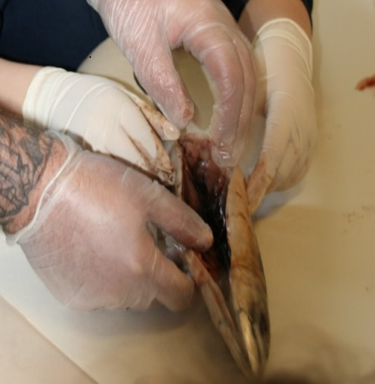
This topic explores the amazing world of Ancient Egypt. As we know you have already studied Ancient Egypt in Year 3, however in Year 5 we focus on the afterlife and how important it was for the Ancient Egyptians. We will be inviting parents in the mummify mackerel too!

Properties of Materials
This exciting science topic investigates different every day materials and includes lots of experiments. We look at different chemical reactions and how we can make changes to materials.
BOOKS
Together, we will read some amazing books; here are just a few of them.
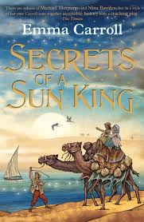
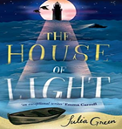

HOMEWORK

Each Thursday, you will receive a piece of maths homework and English homework. You will also get some spellings to learn for a test on a Friday. We expect you to have your homework in by the following Tuesday.

UNIFORM

We want you to always look your best. This means wearing the correct school uniform. Look at these children here, looking their absolute smartest.

BEHAVIOUR

We expect you to be the very best you can be at all times. You will receive dojos for showing us examples of our school values: kindness, pride, integrity, respect, aspiration, independence and courage. By doing this you will earn your termly treat and be in with a chance of winning a seat at the Dojo Café.

TRIPS AND VISITORS

During your time in Year 5, we will invite visitors into our school and go on trips to make our learning even more exciting. Also, for those of you who were originally attending PGL in Year 4, you will have the extra excitement of going this year instead!

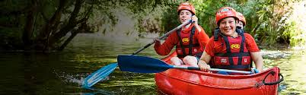

In Year 5, we have an excellent relationship with St. Peter’s Church in Parr. We are lucky enough to visit the church and we also help our community by clearing up the graveyard and doing some gardening! You will have the opportunity to meet Reverend Pauline who provides us with a day of activities around the church!

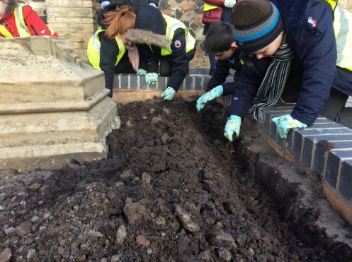
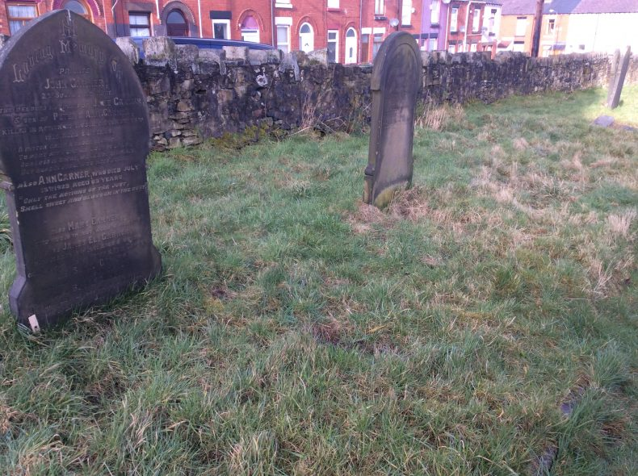

VALUES

As with the whole school, Year 5 is underpinned by our Allanson Street values. Kindness, independence, resilience, integrity, aspiration, respect and pride are all SO important to succeed in Year 5. However, this year we have a new value… COURAGE

Your first task of Year 5 is to research what the word COURAGE means. How can you show courage in school? How can you show courage outside of school? Have your answers ready for the first day of school in September!

We can’t wait to see you in September.
Have a wonderful summer break.

Mr. Regan & Mrs. Onyett

