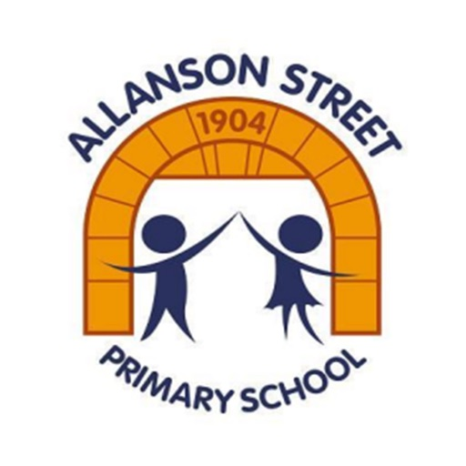

After the holidays, you will be in Year 6.
How exciting!

STAFF
Below are the staff in Year 6.
Any one of them will help you when you need it.
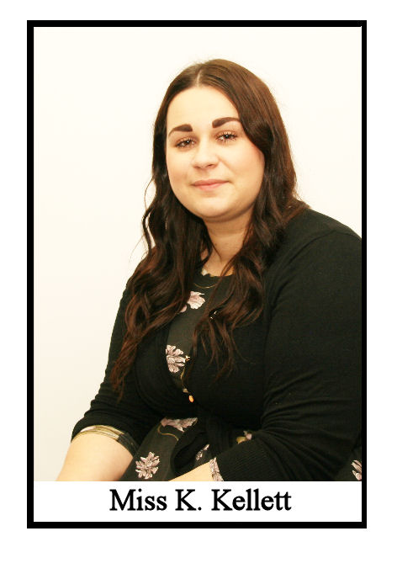
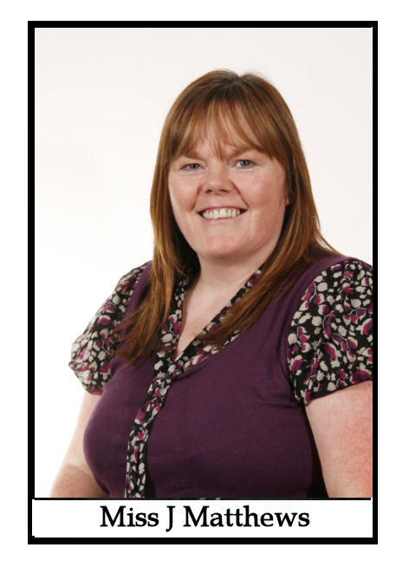
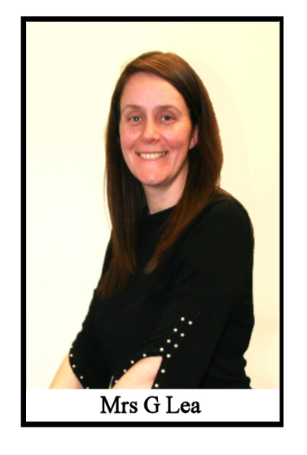
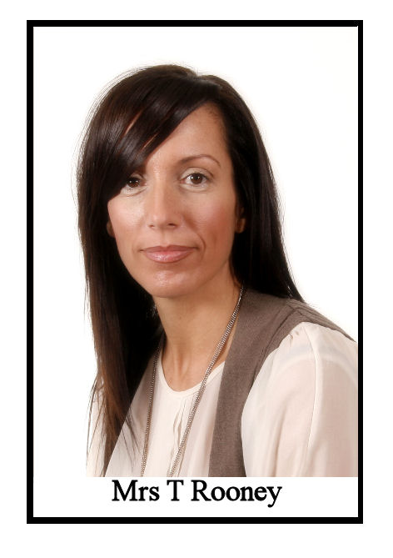
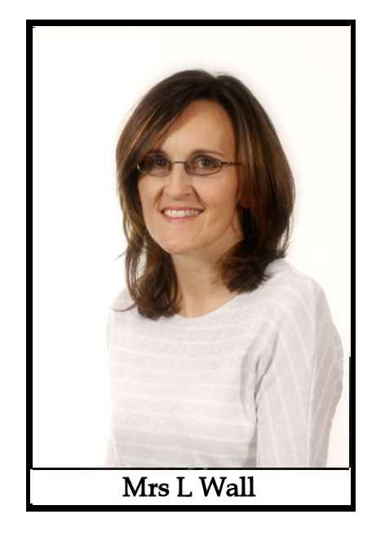
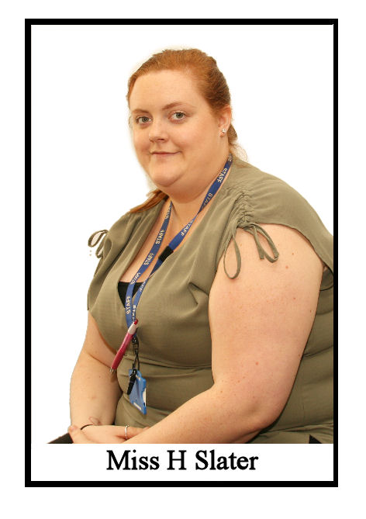
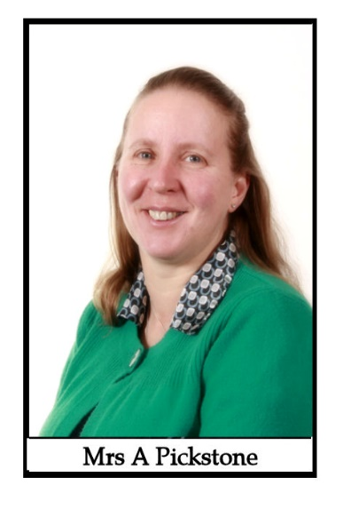

It is our job to help you to be happy, confident young people and we will do anything we can to help you to achieve this.

CLASSROOMS
We love making your classrooms bright and exciting places for you to learn in.

This is Miss Matthews’ classroom.

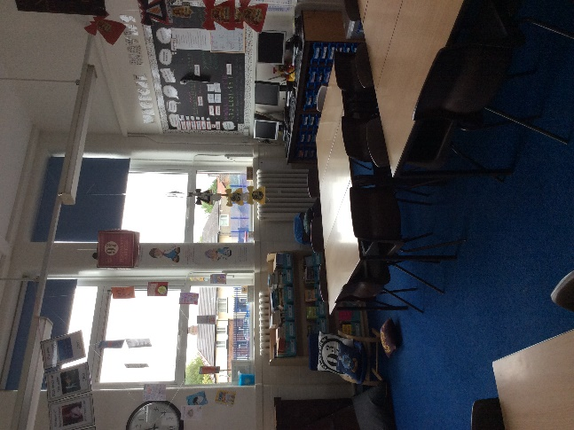
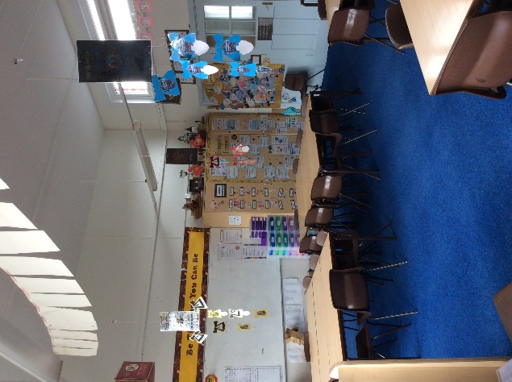
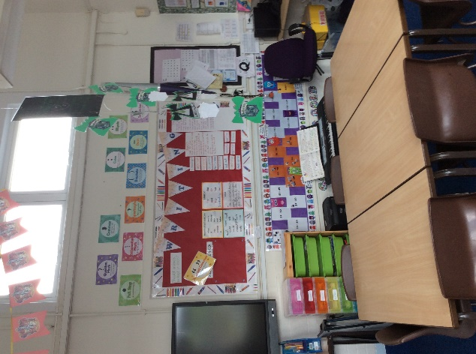

This is Miss Kellett’s classroom.

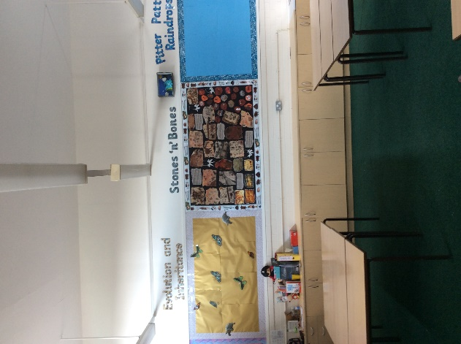
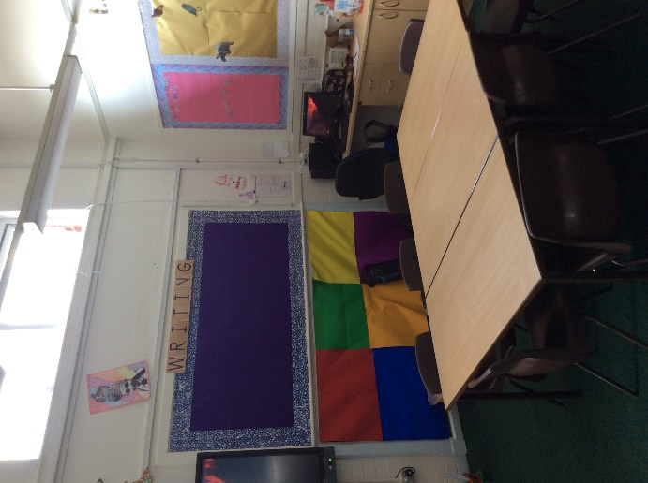
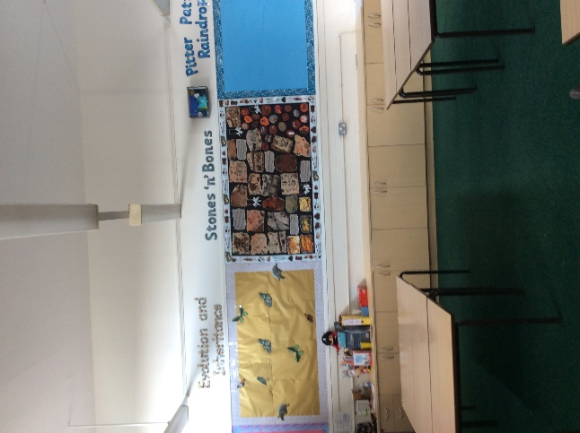

LEARNING
Throughout Year 6, in all of our subjects, you will learn some incredible things. Here is some information about our topics.

Pitter Patter Raindrops
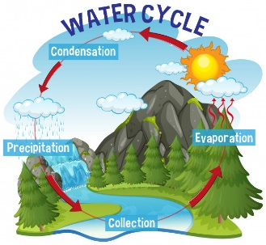
This topic is about the wonderful world of water. We will start our topic by investigating the water cycle. We will even make it rain in a jar!
Did you know
We never get any new water. Every drop of water we use is millions of years old.

Stones ‘n’ Bones
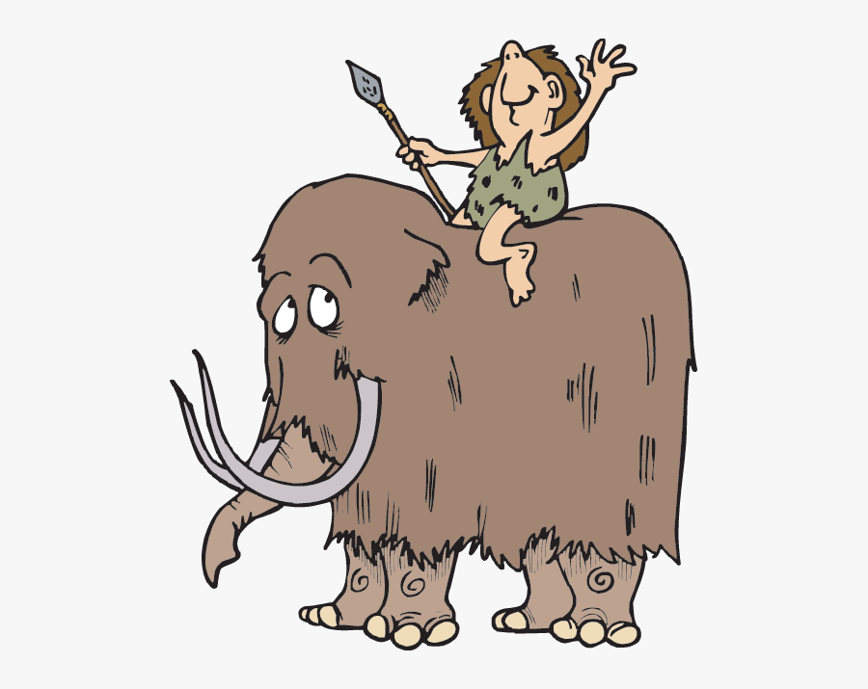
This topic is about how people lived during the Stone Age – how they built houses, how they hunted, how they survived and how they created cave paintings.
Did you know
They used every single part of an animal, even the blood and brains.

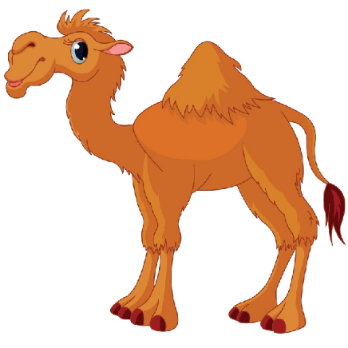
Evolution and Inheritance
Do you know where you got your freckles from, your curly hair or your brown eyes? In this science topic, you will find out. You will also learn how animals adapt to their environment.
Did you know
Camels have long eye lashes to keep the sand out of their eyes.

BOOKS

Together, we will read some amazing books; here are just a few of them.
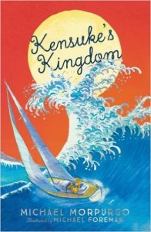
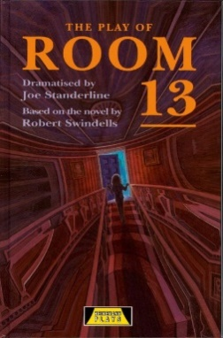
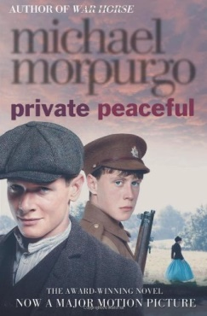
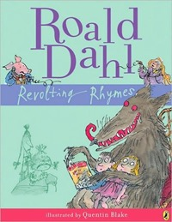
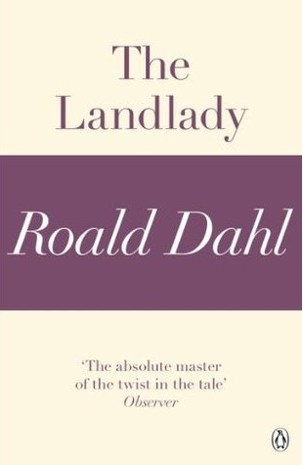

HOMEWORK

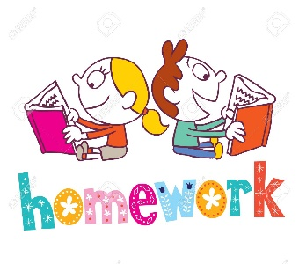
Each Thursday, you will receive a piece of maths homework and English homework. You will also get some spellings to learn for a test on a Thursday. We expect you to have your homework in by the following Tuesday.

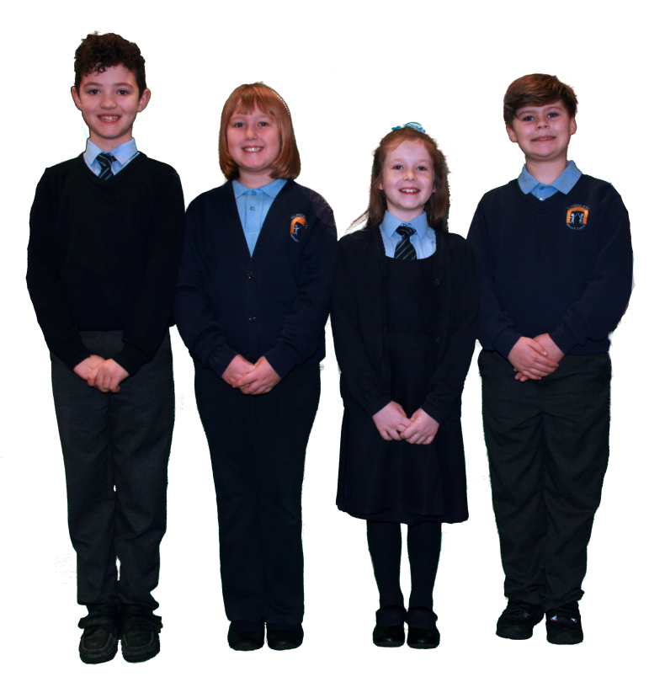
UNIFORM

We want you to always look your best. This means wearing the correct school uniform. Look at these children here, looking their absolute smartest.

BEHAVIOUR

We expect you to be the very best you can be at all times. You will receive dojos for showing us examples of our school values: kindness, pride, integrity, respect, aspiration, independence and courage. By doing this you will earn your termly treat and be in with a chance of winning a seat at the Dojo Café.

TRIPS AND VISITORS

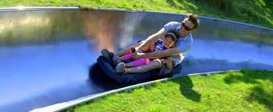
During your time in Year 6, we will invite visitors into our school and go on trips to make our learning even more exciting. Also, at the end of the year, you will have the chance to go on a 3 night trip to York. Those children that choose not to go to York will spend those same 3 days going on exciting trips each day.

Production
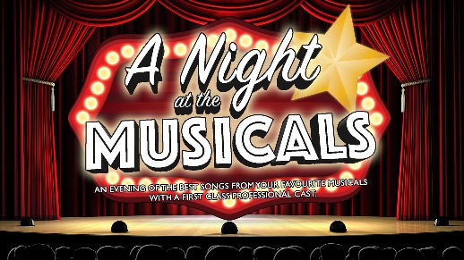
The highlight of our year is our end of year production, ‘A Night at the Musicals’. It’s an opportunity for you all to become singers, dancers and choreographers. It’s so much fun and an incredible end to your Allanson Street journey!

We can’t wait to see you in September.
Have a wonderful Summer break.

