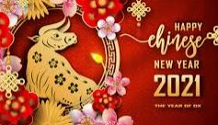
Key texts & events
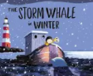
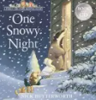
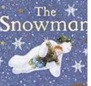

CLLD | PSED | PD | Literacy | Maths | UTW | EAD
1.Understand ‘why’ questions.  2.Sing a large repertoire of songs.  3.Know many rhymes, be able to talk about familiar books, and be able to tell a long story.  4.Listen to and talk about stories to build familiarity and understanding.  5.Retell the story, once they have developed a deep familiarity with the text; some as exact repetition and some in their own words. | 1.Express their feelings and consider the feelings of others  2. Think about the perspectives of others. | 1.Progress towards a more fluent style of moving, with developing control and grace.  2.Develop their small motor skills so that they can use a range of tools competently, safely and confidently.  3.Further develop and refine a range of ball skills including: throwing, catching, kicking, passing, batting, and aiming. | 1.Develop their phonological awareness, so that they can: - spot and suggest rhymes - count or clap syllables in a word - recognise words with the same initial sound.  2.Read individual letters by saying the sounds for them.  3.Write some letters accurately  4.Write own name.  6.Blend sounds into words, so that they can read short words made up of known letter– sound correspondences.  7. Spell words by identifying the sounds and then writing the sound with letter/s. | 1.Count objects, actions and sounds.  2.Subitise.  3. Understand the ‘one more than/one less than’ relationship between consecutive numbers.  4.Link Numerals to quantities up to 10  5.Explore the composition of numbers to 10.  6.Continue, copy and create repeating patterns  7.Compare length, weight and capacity. | 1 Know that there are different countries in the world and talk about the differences they have experienced or seen in photos.  2. Draw information from a simple map  3.Comment on images of familiar situations in the past.  4.Recognise some environments that are different to the one in which they live.  5.Understand the effect of changing seasons on the natural world around them.  6 .Recognise that people have different beliefs and celebrate special times in different ways. | 1. Explore different materials.  2. Develop their own ideas and then decide which materials to use to express them.  3.Respond to what they have heard, expressing their thoughts and feelings.  4.Play instruments with increasing control to express their feelings and ideas.  5.Explore, use and refine a variety of artistic effects to express their ideas and feelings

