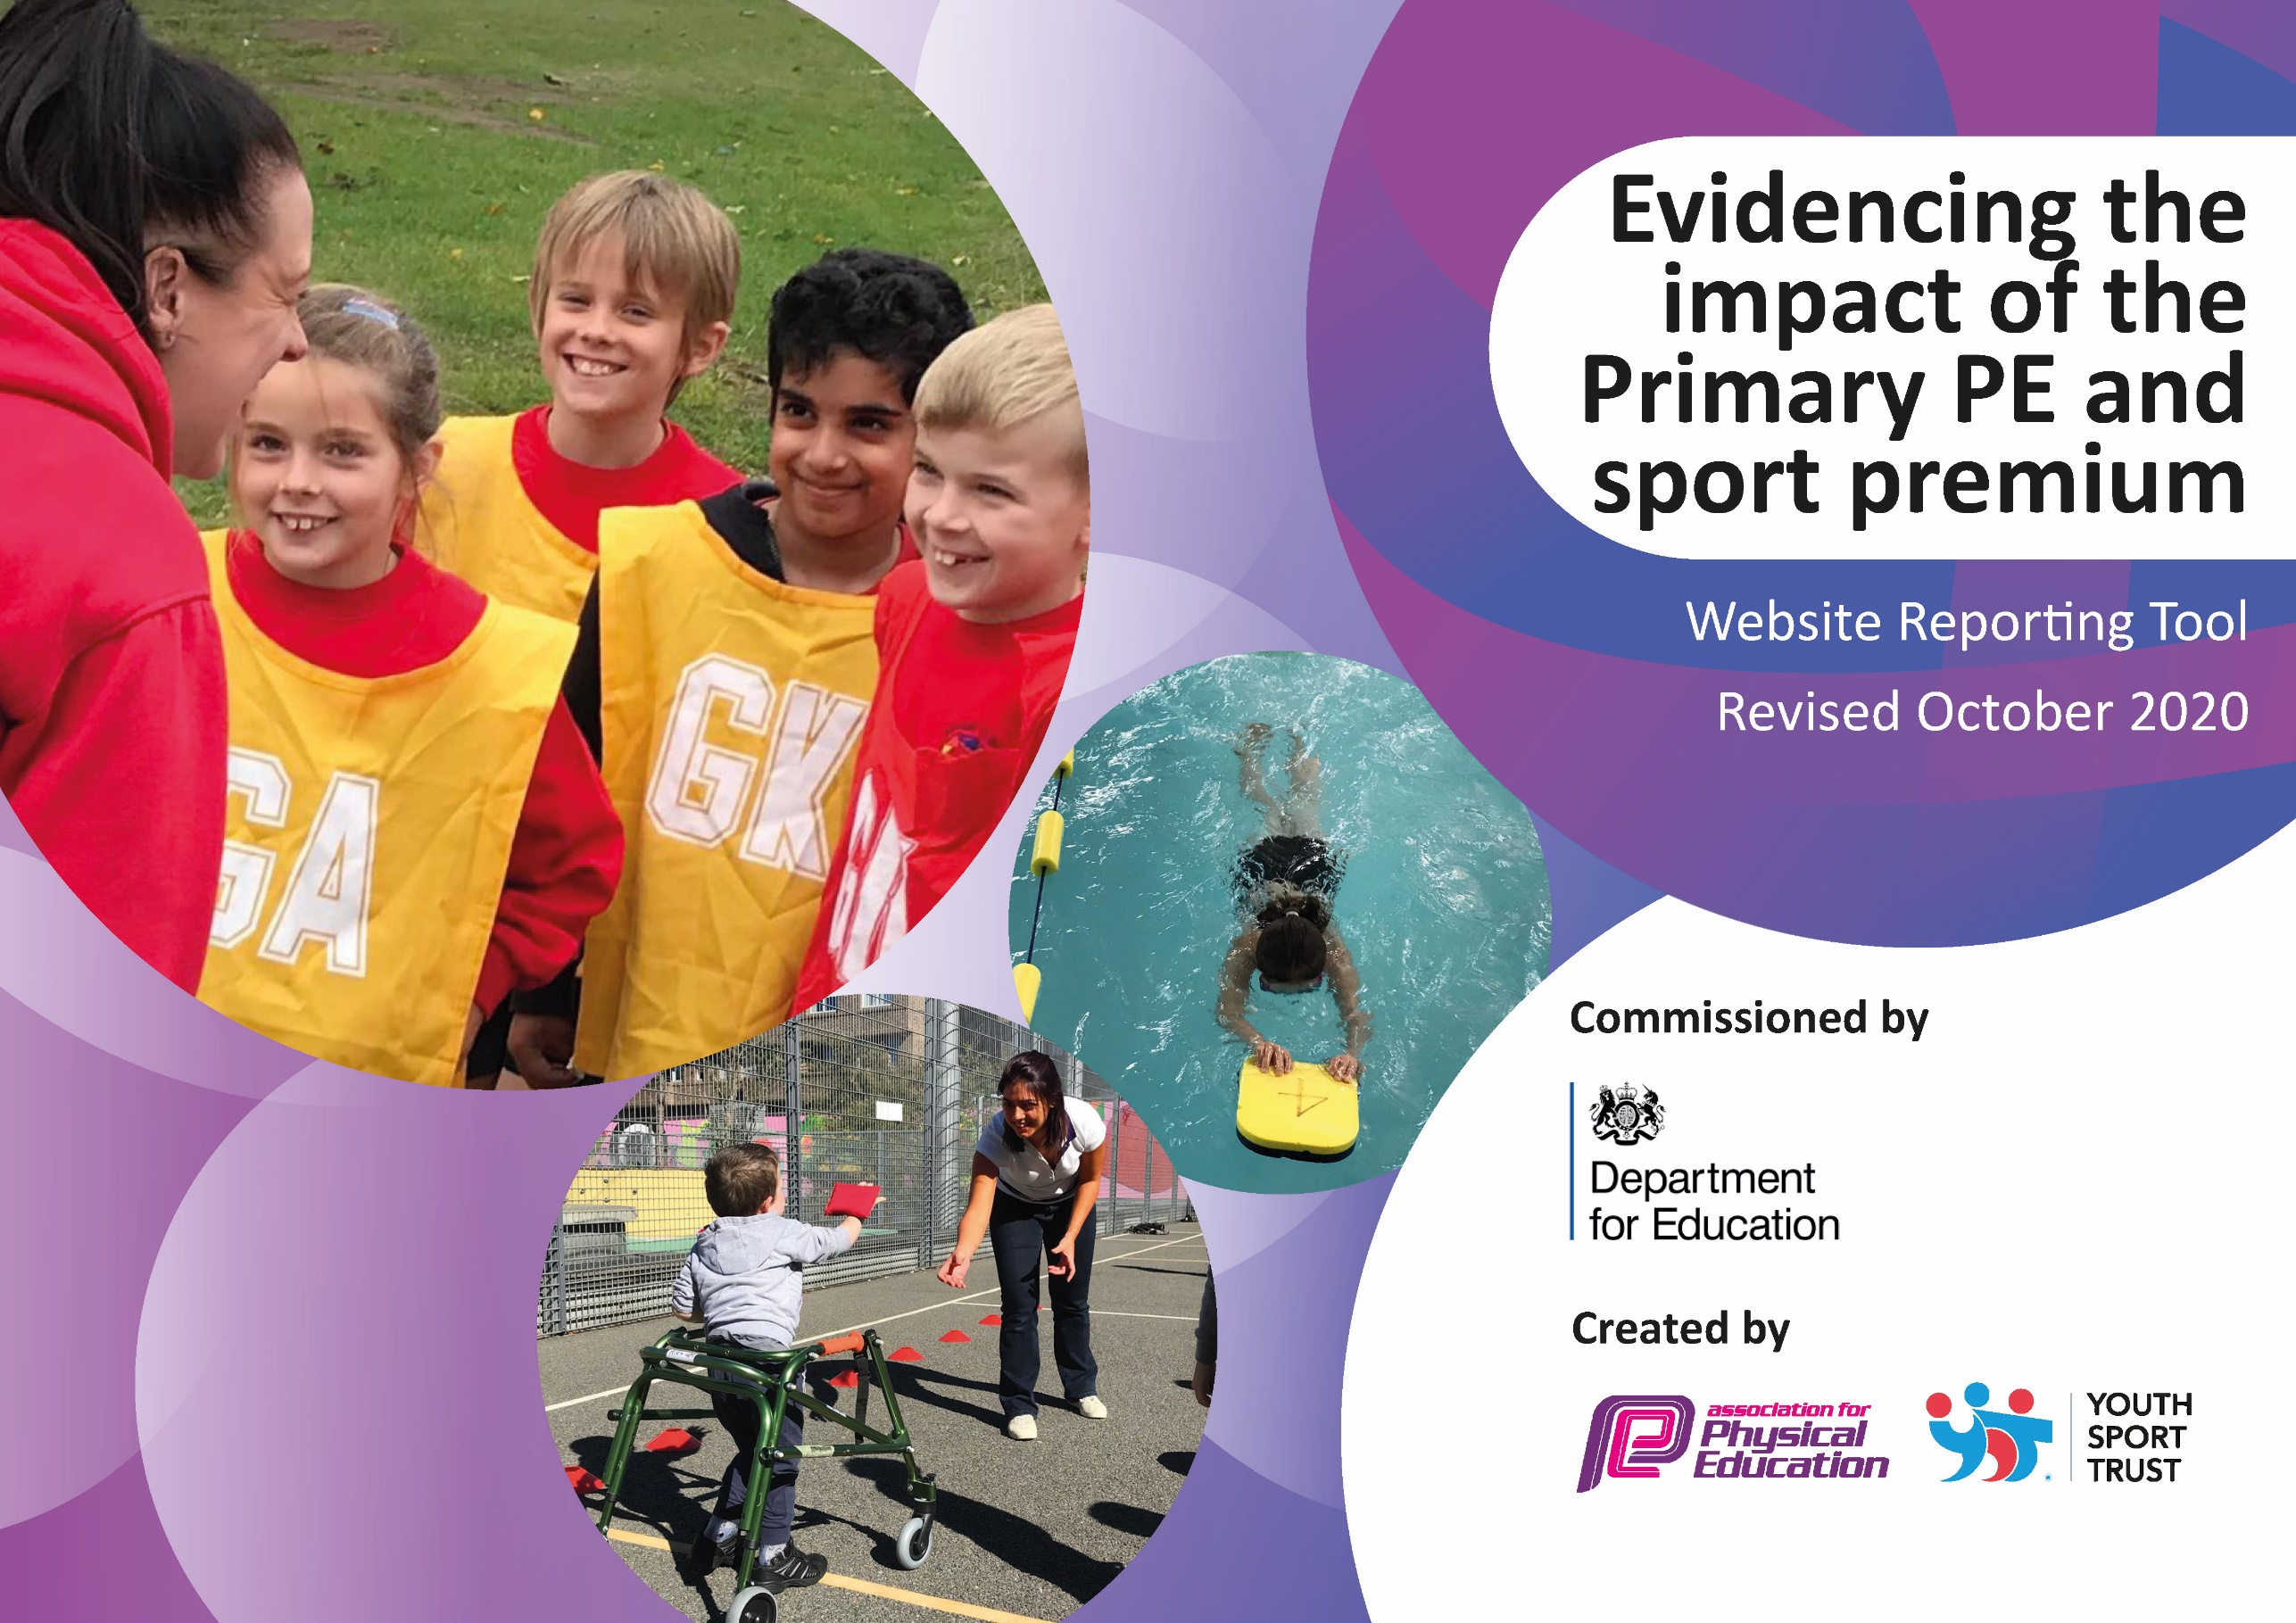
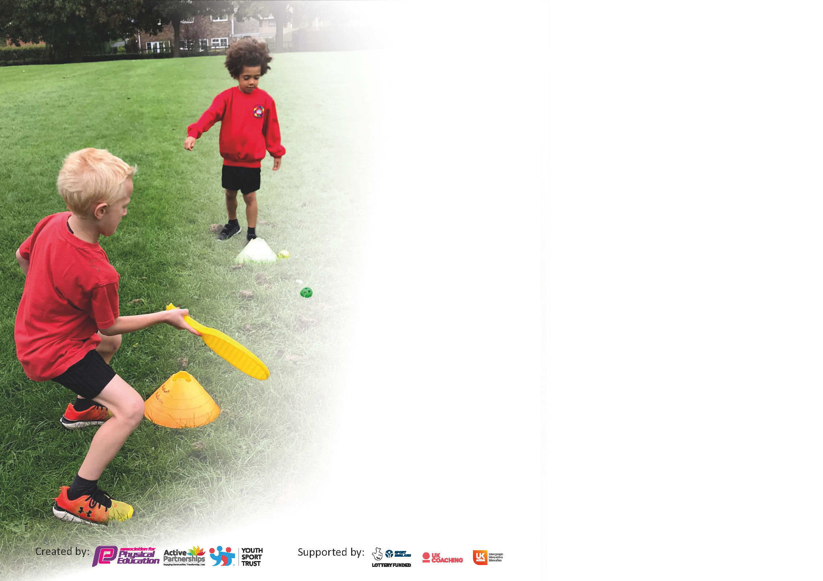

It is important that your grant is used effectively and based on school need. The Education Inspection Framework (Ofsted 2019 p64) makes clear there will be a focus on ‘whether leaders and those responsible for governors all understand their respective roles and perform these in a way that enhances the effectiveness of the school’.

Under the Quality of Education criteria (p41) inspectors consider the extent to which schools can articulate their curriculum (INTENT), construct their curriculum (IMPLEMENTATION) and demonstrate the outcomes which result (IMPACT).

To assist schools with common transferable language this template has been developed to utilise the same three headings which should make your plans easily transferable between working documents.

Schools must use the funding to make additional and sustainable improvements to the quality of Physical Education, School Sport and Physical Activity (PESSPA) they offer. This means that you should use
the Primary PE and sport premium to:

- Develop or add to the PESSPA activities that your school already offer
- Build capacity and capability within the school to ensure that improvements made now will benefit pupils joining the school in future years

Please visit gov.uk for the revised DfE guidance including the 5 key indicators across which schools should demonstrate an improvement. This document will help you to review your
provision and to report your spend. DfE encourages schools to use this template as an effective way of meeting the reporting requirements of the Primary PE and sport premium.

We recommend you start by reflecting on the impact of current provision and reviewing the previous spend.

Schools are required to publish details of how they spend this funding as well as on the impact it has on pupils’ PE and sport participation and attainment by the end of the summer term or by 31st July 2021 at the latest.

** In the case of any under-spend from 2019/20 which has been carried over this must be used and published by 31st March 2021.

We recommend regularly updating the table and publishing it on your website throughout the year. This evidences your ongoing self-evaluation of how you are using the funding to secure maximum, sustainable impact. Final copy must
be posted on your website by the end of the academic year and no later than the 31st July 2021. To see an example of how to complete the table please click HERE.
Created by: Supported by:

Please note: Although there has been considerable disruption in 2020 it is important that you publish details on your website of how you spend the funding - this is a legal requirement.
Support for review and reflection - considering the 5 key indicators from DfE, what development needs are a priority for your setting and your pupils now and why? Use the space below to reflect on previous spend and key achievements and areas for development.

N.B. In this section you should refer to any adjustments you might have made due to Covid-19 and how these will influence further improvement.
Key achievements to date until July 2020: | Areas for further improvement and baseline evidence of need:
- Quality of PE teaching and learning has improved due to staff being supported by, and working alongside, a specialist teacher of PE. This has developed staff’s subject knowledge and their ability to plan and deliver effective programmes of work.  - Staff’s knowledge of planning and delivering PE has increased through purchasing ‘Power of PE’ scheme of work, whereby teachers are now adapting their lessons to suit the needs of their children.  - Children have participated in a wide range of regional challenges and competitions. Children across the school have been successful in the competitions. This has impacted positively on children’s attitudes to, and enjoyment of, sport.  - The number, and range of extra-curricular sporting clubs on offer at any one time has increased.  - The range of sporting opportunities within the curriculum has also increased.  - Extra-curricular clubs have continued to take place in ‘bubbles’, allowing children to continue to participate in sport outside of school hours.  - The quality of inclusive provision has improved thanks to the up-skilling of staff and range of equipment purchased.  - Positive attitudes to health and well-being are now more evident in children throughout the school.  - Profile of sports within and beyond the curriculum has been enhanced and is now shared consistently via the website and Class Dojo.  - Challenge and celebration is now a consistent part of our provision.  - A ‘Virtual Sports Day’ was held during school closure due to Covid-19.  - PE sessions continued to be included in remote learning offer throughout Covid-19 lockdown.  - Years 2,3 & 4 have had specialist rugby league coaching, undertaken by St. Helens R.F.C. Links between school and St. Helens R.F.C are becoming stronger.  - Many classes have now introduced ‘Daily Mile’ as part of their daily timetable.  - Links with Manchester United have been generated, which provides children the opportunity to attend professional football matches with no cost. | - Since Lockdown, children generally have had less opportunities to engage in physical activity. Some of children who have returned to school are less physically fit than before and some appear to have gained weight. We are aware that some children have stayed indoors for long periods of time. Increasing fitness levels will need to be a priority for school in September.  - Staff CPD to remain a priority to ensure high quality teaching.  - PE coordinator to work with sports specialist, within cluster groups and across forums to stay abreast of potential sporting developments.  - Forge links with local high schools and Edge Hill PE department.  - Provide as many extra-curricular opportunities as possible taking into account covid-19 risk assessment.  - Provide feedback to school Governing Body on provision of PE in this academic year.  - If possible, attend as many Level 2 and Level 3 competitions as possible throughout the year (Covid-19 dependent).  - To keep a more accurate record of tournaments and performance.  - To create Inter-house teams so children can still engage in competitions, albeit within school (and maintaining integrity of ‘bubbles’)  - Establish links with local sporting facilities / clubs - e.g. Saints, Sherdley Park Golf Club.  - Update the Sports Premium document and post on the school website.  - Create a more engaging PE display to highlight the key achievements of PE and physical activity across the school.  - Review how many children are attending out of school sports clubs. Analyse numbers to ensure provision meets need – e.g. clubs are fully inclusive.  - Promote lifelong healthy active lifestyles through PE.  - Promote C4L.  - PE lead to send questionnaire to staff regarding their confidence/understanding of teaching PE.

Did you carry forward an underspend from 2019-20 academic year into the current academic year? NO * Delete as applicable

If YES you must complete the following section
If NO, the following section is not applicable to you

If any funding from the academic year 2019/20 has been carried over you MUST complete the following section. Any carried over funding MUST be spent by 31 March 2021.
Academic Year: September 2020 to March 2021 | Total fund carried over: £ | Date Updated:
What Key indicator(s) are you going to focus on? |  |  |  | Total Carry Over Funding:
 |  |  |  | £
Intent | Implementation |  | Impact
Your school focus should be clear how you want to impact on your pupils. | Make sure your actions to achieve are linked to your intentions: | Carry over funding allocated: | Evidence of impact: How can you measure the impact on your pupils; you may have focussed on the difference that PE, SS & PA have made to pupils re-engagement with school. What has changed?: | Sustainability and suggested next steps and how does this link with the key indicators on which you are focussing this academic year?:

Meeting national curriculum requirements for swimming and water safety.

N.B Complete this section to your best ability. For example you might have practised safe self-rescue techniques on dry land.
What percentage of your current Year 6 cohort swim competently, confidently and proficiently over a distance of at least 25 metres?  N.B. Even though your pupils may swim in another year please report on their attainment on leaving primary school at the end of the summer term 2021. | %
What percentage of your current Year 6 cohort use a range of strokes effectively [for example, front crawl, backstroke and breaststroke]? | %
What percentage of your current Year 6 cohort perform safe self-rescue in different water-based situations? | %
Schools can choose to use the Primary PE and sport premium to provide additional provision for swimming but this must be for activity over and above the national curriculum requirements. Have you used it in this way? | Yes/No

Action Plan and Budget Tracking
Capture your intended annual spend against the 5 key indicators. Clarify the success criteria and evidence of impact that you intend to measure to evaluate for pupils today and for the future.

Academic Year: 2020/21 | Total fund allocated: £19,478 | Date Updated: Dec 20
Key indicator 1: The engagement of all pupils in regular physical activity – Chief Medical Officers guidelines recommend that primary school pupils undertake at least 30 minutes of physical activity a day in school |  |  |  | Percentage of total allocation:
Intent | Implementation |  | Impact | 0%
Your school focus should be clear what you want the pupils to know and be able to do and about  what they need to learn and to  consolidate through practice: | Make sure your actions to achieve are linked to your intentions: | Funding allocated: | Evidence of impact: what do pupils now know and what can they now do? What has changed? | Sustainability and suggested next steps:
- To give children opportunities to get active during lessons.  - The engagement of all pupils in regular physical activity – kickstarting healthy active lifestyles. | - Allanson Street teachers to have access to ‘GoNoodle’, which provides short brain breaks for children to be active in the classroom. PE lead to send resources from ‘Active Learning’ and any other resources found to enable children to be active during l lessons.  - C4L club to be delivered daily to children increasing pupil activity levels at lunch time. | - £0  - £0 | - Pictures to be taken of children active during lessons. PE lead to monitor the impact of this through discussions with class teachers.  - C4L plans and registers for children who are participating in the activities. A timetable to be created for designated C4L slots. | - Continue to provide children with the opportunity to be active during lessons and provide further resources so the activities do not become repetitive for the children.  - Ensure current Y5’s are trained in leading C4L clubs by PE lead and sports apprentice.
Key indicator 2: The profile of PESSPA being raised across the school as a tool for whole school improvement |  |  |  | Percentage of total allocation:
 |  |  |  | £397 = %
Intent | Implementation |  | Impact
Your school focus should be clear what you want the pupils to know and be able to do and about  what they need to learn and to  consolidate through practice: | Make sure your actions to achieve are linked to your intentions: | Funding allocated: | Evidence of impact: what do pupils now know and what can they now do? What has changed?: | Sustainability and suggested next steps:
- To raise aspirations in sport throughout the school.  - Celebration of achievement. Ensure the whole school is aware of the importance of PE within school.  - Audit of PE equipment and provide new and engaging resources.  - Pupil voice – consult with children about the sports that they would like to participate in for extra-curricular activities.  - Children to understand the importance of PE and Sport in a whole world context.  - All children to recognise the importance of leading a lifelong healthy, active lifestyle.  - Improved role modelling of healthy active lifestyle behaviours by all school staff to reach all children. | - School visits from professional sportsmen/women to give talks to the children. Preferably from professionals from the local area to allow children to recognise that they can be successful in sport, regardless of the area in which they live in.  - Introduce ‘Coach’s Sportsperson of the Week’ during Friday’s celebration assembly. Sports Apprentice to recognise 2 children they have taught this week who have stood out to them during their PE lessons.  - Achievements celebrated in assembly, match results etc. Out of school and after school sport celebrated.  - Keep PE display board up to date with recent achievements of children in competitions and sport outside of school.  - A range of new resources provided to engage and inspire the participation of PE.  - Children will have more say in what sports takes place in school.  - Activities to be planned around the different sporting events in the coming year – Olympics and Paralympics, European Football Championships etc.  - Fit4Kids health and fitness workshop delivered to Y3,4&5 to teach children the importance of leading a healthy, active lifestyle.  - PE subject focus: “To encourage children to lead a lifelong healthy, active lifestyle.”  - Staff to encourage children to choose healthy meal options. Staff to award Dojo’s for healthy choices/snacks. | - £ TBC  - £0  - £TBC  - £0  - £0  - £397 | - Children to link English topic to the sportsman/woman who has delivered a talk. E.g. How have they been inspired? Biography/research  - Achievements recorded by sharing the information on ClassDojo for parents.  - More children to engage in PE and Sport and take part in lunchtime activities and after school clubs.  - Questionnaires will show the impact of change and sport/PE will have a high profile in school.  - Record participation in whole school activity days via work and ClassDojo updates. | - Forge positive relationships with various professional sports clubs around St. Helens/Merseyside.  - Ensure this is followed through in weekly assembly.  - Annual review of resources.  - Regular review of questionnaires from children.

Key indicator 3: Increased confidence, knowledge and skills of all staff in teaching PE and sport |  |  |  | Percentage of total allocation:
 |  |  |  | £17,910 = %
Intent | Implementation |  | Impact
Your school focus should be clear | Make sure your actions to | Funding | Evidence of impact: what do | Sustainability and suggested
what you want the pupils to know | achieve are linked to your | allocated: | pupils now know and what | next steps:
and be able to do and about | intentions: |  | can they now do? What has
what they need to learn and to |  |  | changed?:
consolidate through practice:
- Improved quality of children's PE across the school to ensure all teachers are competent and confident in the delivery of PE.  - To provide quality coaching delivered by professionals. | - Hiring of sports specialists to work alongside teachers and teaching assistants in a CPD role, during the delivery of class PE. PE specialists employed – Lucy for Dance/David Campbell Sports Apprentice for Gymnastics and other sports. Access to access termly CPD in PE  - Purchase ‘Power of PE’ scheme of work. PE planning to enable school to deliver a broad and balanced PE curriculum.  - PE subject leader to plan and undertake a series of lesson observations and/or team teaching with teachers to look at teaching, learning and assessment in physical education.  - Work in partnership with SCDF & Sky Try to provide high quality rugby league coaching sessions for Y2,3&4. Teachers to attend these sessions with their class to gain ideas for future rugby PE lessons. | David Campbell Sports Apprentice Gold Package - £8,000  plus 2 x 20 £2 per child weekly £1,280  £1,280  Dance £7,000  Golf TBC  Power of PE Scheme £350  - £0 | - All classes taking part in one PE lesson under guidance of sports specialists. Teachers have worked alongside specialists to team teach during PE lessons. Staff meeting discussion has shown that teachers feel more confidence in delivering their own PE as a result.  - Constructive lessons observation feedback given to teachers from PE lead.  - Units of work on staff share. Attendance at CPD session with evaluation forms completed. | - Continue with hiring of specialists.  - PE lead to send any CPD opportunities to staff.  - PE lead to arrange dates in new calendar of staff meetings.  - To maintain links with local sports providers.  - Keep in regular contact with St. Helens School Games.  - Continue positive relationship with SCDF and accept future invitations for their sessions.
Key indicator 4: Broader experience of a range of sports and activities offered to all pupils |  |  |  | Percentage of total allocation:
 |  |  |  | £2194 = %
Intent | Implementation |  | Impact
Your school focus should be clear | Make sure your actions to | Funding | Evidence of impact: what do | Sustainability and suggested
what you want the pupils to know | achieve are linked to your | allocated: | pupils now know and what | next steps:
and be able to do and about | intentions: |  | can they now do? What has
what they need to learn and to |  |  | changed?:
consolidate through practice:
- To increase the percentage of children able to meet the national curriculum expectations in PE.  - Introduce more KS1 and lower KS2 clubs. Sports coaches to broaden the sports they cover. | - Provide additional swimming lessons for those children who need more time to meet the national expectations for swimming.  - Develop an assessment tracking spreadsheet to monitor progress in swimming and be able to target children for addition swimming intervention.  - Focus on inclusive activities. Allow children to have a voice in extra-curricular clubs the school offers. | - £2194  - £0 | - To increase the percentage of pupils who can meet the following:  - Perform safe self-rescue in different water-based situations  - Swim competently, confidently and proficiently over a distance of at least 25 metres  - Use a range of strokes effectively, for example, front crawl, backstroke and breaststroke.  - Are children who don’t regularly attend after school clubs now attending? Register of children attending. | - Keep a register of attendance.

Key indicator 5: Increased participation in competitive sport |  |  |  | Percentage of total allocation:
 |  |  |  | £3450 = %
Intent | Implementation |  | Impact
Your school focus should be clear | Make sure your actions to | Funding | Evidence of impact: what do | Sustainability and suggested
what you want the pupils to know | achieve are linked to your | allocated: | pupils now know and what | next steps:
and be able to do and about | intentions: |  | can they now do? What has
what they need to learn and to |  |  | changed?
consolidate through practice:
- Develop teams to enter a wide variety of LV2 events and qualify for LV3.  - To compete in St. Helens virtual school games competitions, with a chance of qualifying for Merseyside school games competitions.  - Enhanced provision package organised through SHAPES and SGO’s.  - All children to take part in an intraschool house competition that will feature a range of sports and boost competition.  - Remove barriers which prevent some children from attending competitive sports. | - Ensure all year groups are represented to attain maximum participation.  - PE coach to be released to help run the competitions (lunchtimes and regular PE slots to be used).  - Enter all SSP School Games events and promote through website & ClassDojo.  - Sports coach and subject leader to Identify sports and activities that would fit within an intra-school competition – create a calendar of events.  - Use of the mini-bus to transport pupils to competitive events and sporting activities. | - SHAPES premium membership - £950  - £0  - Transport – £2,500 | - Record of SGO table of competition.  - Record intraschool competitions and celebrate achievements. | - School will sign up for enhanced local school games package next year.  - Continue to utilise the services of PECO Schools Network provider in the organisation and attendance of competitions.  - Staff PE lead to support class teachers in the delivery of intra school competitions.  - Ensure a format is set up to enable this to continue for the foreseeable future.

Signed off by
Head Teacher: | L. Dingsdale
Date: | 30.12.20
Subject Leader: | Aaron Regan
Date: | 30.12.20.
Governor: | A Lashley
Date: | 30.12.20

