Pupil premium strategy statement

Before completing this template, you should read the guidance on using pupil premium.

Before publishing your completed statement, you should delete the instructions (text in italics) in this template, including this text box.

This statement details our school’s use of pupil premium (and recovery premium for the 2021 to 2022 academic year) funding to help improve the attainment of our disadvantaged pupils.

It outlines our pupil premium strategy, how we intend to spend the funding in this academic year and the effect that last year’s spending of pupil premium had within our school.

School overview
Detail | Data
School name | Allanson Street Primary School
Number of pupils in school (excluding Nursery children) | 408 (2021 - 2022)  411 (2022 – 2023)
Proportion (%) of pupil premium eligible pupils | 51%  52%
Academic year/years that our current pupil premium strategy plan covers (3-year plans are recommended) | 2021/2022  2022/2023  2023/2024
Date this statement was published | November 2021
Date on which it will be reviewed | Interim review:  December 2022  December 2023  Full review: December 2024
Statement authorised by | Lynsey Dingsdale  Headteacher
Pupil Premium lead | Michelle McLoughlin
Governor / Trustee lead | Shirley Nield  Co Chair of Governors

Funding overview
Year 1: 2021-2022
Detail | Amount
Pupil premium funding allocation this academic year | £267,138
Recovery premium funding allocation this academic year | £15,624
Pupil premium funding carried forward from previous years (enter £0 if not applicable) | £0
Total budget for this academic year  If your school is an academy in a trust that pools this funding, state the amount available to your school this academic year | £282,762  NA
Year 2: 2022-2023
Detail | Amount
Pupil premium funding allocation this academic year | £305,843
Recovery premium funding allocation this academic year | £32,081
Pupil premium funding carried forward from previous years (enter £0 if not applicable) | £0
Total budget for this academic year  If your school is an academy in a trust that pools this funding, state the amount available to your school this academic year | £337,924

Part A: Pupil premium strategy plan

Statement of intent
At Allanson Street Primary School, our intent is to give every child the life chances they deserve regardless of their starting point or the obstacles they may encounter. By doing this, we aim to ensure that children leave us well equipped with the knowledge, skills and values needed to become happy, confident, productive citizens ready and willing to make a positive contribution to the world.
We serve a local area that falls within the top 1% most deprived areas nationally (Indices of Deprivation 2019). Many of our children live in economically challenging circumstances and experience daily the pressures of those circumstances. Unfortunately, this means that our children face a wide range of barriers to their learning and, too often, require early help and social care involvement.

We are committed to providing a highly inclusive, nurturing environment where every child can reach their full potential.
To achieve this, we first ensure that our children’s basic needs are met. A strong pastoral team, consisting of designated safeguarding lead teacher, pastoral manager, two pupil mentors and a sports coach, give children and their families the confidence to feel safe and well supported. Family support and nurture provision enables us to develop new relationships with vulnerable children and families. In addition, we provide a free breakfast club and unicycle provision to ensure that all of our children have a positive start to the day. We also work well with external agencies such as children’s social care, speech and language teams and specialist teachers to ensure our children receive the very best support available.
We have constructed a curriculum that prioritises rich vocabulary and reading for pleasure, builds progressive knowledge that can be retained and enables children to find their passions and raises aspirations. To ensure the effective delivery of this, we aim to invest in quality, targeted CPD for all staff and support staff through rigorous appraisal to ensure that every child benefits from quality first teaching. In addition, every child has access to a cultural pathway which provides regular opportunities to promote and embed spiritual, moral and cultural development and the development of our school and British values.
We understand that disadvantaged children have been worst affected by partial school closures and that the attainment gap has grown as a result of National Lockdowns (EEF, 2021). We have continued to focus on overcoming any impact on our vulnerable and disadvantaged children, carefully monitoring the progress of groups and individuals.
Our focus is:
- To develop children’s metacognitive skills to motivate them as learners, help them to think creatively and increase their resilience when faced with a problem.
- To ensure that feedback is used by teachers to support children’s progress, building learning, addressing misconceptions, and thereby closing the gap between where a child is and where we know they can be.
- To develop children’s vocabulary and oracy skills as a means to communicate their thoughts and ideas and as an essential building block to improving reading and writing.
The key principles underpinning our approach are:
- That our pupil premium strategy links to all other aspects of our whole school strategic planning.
- Our actions are evidence-based on national research.
- A relentless focus on the development of a high-quality curriculum and teaching and learning is achieved through high quality training and support.
- Our actions are measurable with clear success criteria.
- That all members of our community are aware of the desired outcomes of our plan, how we will achieve them and the roles they play.
- That our plan will be responsive and flexible to meet any changing local and national needs.

Challenges

This details the key challenges to achievement that we have identified among our disadvantaged pupils.
Challenge number | Detail of challenge
1 | Poor speech, language and communication  Low level language skills have been exacerbated by Lockdown / Partial Lockdowns – Whole School Priority.  The high prevalence of speech, language or communication needs among disadvantaged children is thought to contribute to the achievement gap that exists by the time children enter school and continues until they leave.  At Allanson Street, we are acutely aware of the 30 million word gap by age 3 (Hart and Risley 2003). Upward of 50% of children starting school have language skills that are underdeveloped for their age. This language delay hampers children’s ability to learn, achieve and make friends. It significantly impacts on their literacy and numeracy development. Children have difficulty listening, paying attention, poor vocabulary, difficulty understanding language, difficulty organising and using language, immature sentences and difficulty taking turns.
2 | Attendance  Improving attendance, has historically been a significant challenge and this was exacerbated by Covid 19. Our attendance for 2020-2021 was below national average (93.07%) and the number of persistent absentees was significantly above national average (24%)
3 | Limited life experiences  Growing up in poverty means that many children at Allanson Street have a limited experience of cultural capital. Exploring their own town/local area and expanding their horizons to include visits to a range of places and experiences has traditionally been limited. At Allanson Street we recognise the importance of our children acquiring a wealth of knowledge, behaviours and skills which give them the desire to dream big and aim high regardless of their starting points.
4 | Lack of readiness to learn  We recognise that some of our children have reduced self- regard of themselves as learners and therefore do not enter school physically, mentally or emotionally ready to learn. This significantly impacts the progress they make and, in some cases, their enjoyment of school life and willingness to attend. At Allanson Street we aim to provide a wealth of opportunities to engage children, improve their general knowledge and boost their self-regulation and metacognitive skills therefore equipping them with lifelong skills and developing their self-esteem and aspirations.
5 | Low aspirations of both parents and children – academically, personally and behaviourally.  Living in poverty means that low expectations and aspirations of parents / carers, particularly in terms of behaviour and educational achievement, are not unusual. The ratio of parents who attended higher education is extremely low and, for many children, they would be the first to aim for higher education. At Allanson Street we aim to provide our children with a stable, secure, nurturing, aspirational environment which equips them with the skills and confidence to be able to overcome difficulties in adult life and strive to make a positive contribution to their workplace and community.

Intended outcomes
This explains the outcomes we are aiming for by the end of our current strategy plan, and how we will measure whether they have been achieved.
Intended outcome | Success criteria
To ensure all children, particularly those who are disadvantaged, achieve at least 96% attendance. To reduce persistent absenteeism to 10%. Getting children into school regularly will ensure that children receive a full education including any planned interventions and cultural experiences. This will ensure further gaps in learning are avoided and prepare children for the world of work. | Adults and children will understand the impact of good attendance and punctuality has on children achieving their full potential.  The attendance of disadvantaged children will be in line with national and school data for attendance and punctuality at 96%.  A significantly reduced number of pupil premium children will be persistent absentees.  Children’s good attendance will reflect in improved attainment across the curriculum. For some children, we would also expect to see improved self-regulation and personal, social skills.
Feedback used effectively to enable children to develop a greater independent awareness of strategies for improving.  Feedback will focus on the task, subject and self-regulation strategies providing the children with specific information on how to improve. | All staff will have a clear understanding of how to deliver effective, targeted, appropriate feedback.  Children will use feedback to develop their knowledge, understanding and application of key concepts therefore improving their attainment across the curriculum.
Children will be able to understand and use a wider, richer vocabulary which includes increasingly complex subject specific vocabulary within each topic. | All staff have a strong grasp of standard English and subject specific vocabulary for their year group.  Gaps in children’s spoken language are identified and the ‘vocabulary gap’ is reduced.  Children are able to use ambitious, subject specific vocabulary when answering questions and participating in discussions.  Children have an increased capacity to speak, read and write like the artists, scientists, tradespeople and historians they aspire to become.  Children will have good communication skills enabling them to:  work well as a team  make a confident, age- appropriate class/assembly presentation  listen properly to others and respond  Children will develop their love of reading and improve their ability to talk richly about books.
Children to develop metacognitive skills to motivate them as learners, help them to think creatively and increase their resilience when faced with a problem. | Pupil premium children with limited learning to learn skills will be identified early and receive the appropriate level of support to develop their ability to fully access and enjoy the curriculum.
The bedrock of our curriculum design will be the cultural capital children need to build upon and develop their existing knowledge base. | Children will take part in a free annual experience which will enhance and develop their learning, language and understanding of the wider world.  Cultural capital will be an integral part of our curriculum design.

Activity in this academic year
Year 2: 2022 - 2023
This details how we intend to spend our pupil premium (and recovery premium funding) this academic year to address the challenges listed above.

Teaching (for example, CPD, recruitment and retention)
Budgeted cost: £17,129
Activity | Evidence that supports this approach | Challenge number(s) addressed
Curriculum Development  To ensure each subject leader has the opportunity to work with experts from SIL to develop their curriculum area. | Ofsted research defined a ‘knowledge-rich’ approach as one in which curriculum leaders are clear on the ‘invaluable knowledge they want their pupils to know’. Through engaging in targeted CPD staff will develop their ability to plan and support each other in the delivery of a progressive, successful curriculum which supports pupils in essential vocabulary development and retention, remembering what they have been taught and encourages them to aspire to learn, know and do more both at school and in adult life. | 1, 3, 4, 5.
Feedback (CPD)  To continue to develop our use of effective, targeted feedback which will enable children to make progress. | EEF research suggests the average impact of effective feedback strategies is an additional 6 months’ progress over the year.  Staff will develop their skills in delivering high quality feedback which focuses children’s attention on the task, subject and self-regulation strategies both when work is correct and incorrect. | 1, 4, 5.

Targeted academic support (for example, tutoring, one-to-one support structured interventions)
Budgeted cost: £221,531
Activity | Evidence that supports this approach | Challenge number(s) addressed
Phonics Intervention team to provide monitored intervention to ensure support is targeted on the specific areas needed to improve. | Evidence indicates that teaching phonics is the best way to enable children to read with effective phonics teaching adding an additional 5 months’ progress. The EEF guidance recommends that all schools use a systematic approach to teaching it.  Rigorous monitoring by designated lead teachers ensures that intervention is purposeful, timely and effective in moving children on to the next stage of their reading journey thus ensuring they develop the early skills necessary to read widely and for enjoyment. | 1, 3.
Comprehension Intervention team to provide targeted academic support to explicitly link structured 1:1/small group tasks to the principals of the ‘SHINE’ (Are you really reading?) programme. | EEF research suggests that reading comprehension strategies add an additional 6 months’ progress over the year. Studies have shown that children eligible for FSM may receive additional benefits from being taught how to use a variety of reading comprehension strategies effectively.  A whole school approach to the teaching of comprehension using the ‘SHINE’ principals has now been adopted which is aimed at supporting all children, especially our most vulnerable, in developing their comprehension skills and understanding how to answer standard assessment questions. | 1, 4.
Tutoring for children in reading and maths from Years 3 – 6 to enable them to keep up and progress with their learning.  Tutoring to be provided by school staff and tutors from Tutor Trust. | EEF research suggests tuition targeted at specific needs and knowledge gaps can be an effective way of supporting children who are at risk of falling behind. | 1, 4, 5.

Wider strategies (for example, related to attendance, behaviour, wellbeing)
Budgeted cost: £99,210
Activity | Evidence that supports this approach | Challenge number(s) addressed
Attendance team led by RG will provide targeted support for children who are classed as persistently absent and ensure rates of attendance are raised. | Centre for social justice research highlights the impact of Covid 19 on school attendance with the phrase- ‘kids can’t catch up if they don’t show up’. If children miss school, they are deprived of the opportunity to form relationships with their peers and the chance to make vital links between their learning. | 2.
Extra- curricular activities provided to ensure pupil premium children have access to a range of activities and opportunities.  ‘Steps to Success’ programme will also provide an extra, added opportunity for children and their families to work together to aspire to ‘graduate’ from Edge Hill university in the summer term. | EEF research suggests that physical activity has a wealth of benefits in terms of supporting physical health, mental health and overall wellbeing. Children from disadvantaged backgrounds may be less likely to attend after school clubs within the local community due to financial and travel restrictions therefore by offering sporting clubs and activities free of charge we are bridging the gap and offering our children an important experience that otherwise might not be available to them.  Steps to Success aims to further capitalise on this by introducing our most disadvantaged children to the opportunities available for further education and careers in a wide range of areas they might not previously have been aware of and motivating them to aspire to achieve these. | 3, 4, 5.
First Steps family club will provide pre-school children and families with the opportunity to engage and model good ‘ready to learn’ strategies/basic skills before entry to Nursery. | EEF research suggests that beginning early years education at a younger age appears to have a high positive impact on learning outcomes. Running a low- cost weekly family club for pre-school encourages parents who may be wary of school to engage with staff in a non-threatening way, building relationships and accessing support they may need. Staff model high quality interactions, simple, free games and activities to boost early vocabulary, literacy, numeracy and PHSE while ensuring parents feel safe and comfortable enough to talk and explore new ideas. | 1, 3, 4, 5.
Education enriching experiences provide children with greater access to cultural and events beyond the classroom thus broadening their horizons, raising aspirations and developing their speech and language. | OFSTED research on the importance of cultural capital opportunities discusses the importance of raising individuals who are knowledgeable about a wide range of culture, comfortable discussing its value and merits, and have been given a vast array of experiences and access to skill development. | 1, 3, 4, 5.
WellComm Language purchase/assessments will focus interventions directly on those children who need them most to progress. | EEF evidence suggests that children from lower socioeconomic backgrounds are more likely to be behind their more advantaged peers in developing early language and speech skills which may affect their school experience and learning later in their new lives. Embedding WellComm language and activities from Early Years upwards and throughout school as needed will develop children’s essential communication and vocabulary skills. | 1.
SDQ assessments and intervention will support targeted children with developing strategies to deal with social, emotional and behavioural issues which impact on their ability to learn. | EEF research indicates that social and emotional learning approaches have a positive impact on average of 4 months’ additional progress over the course of a year. Equipping children with the skills and strategies to effectively understand and regulate their own emotions will have a significant impact on both their overall wellbeing and attitudes to learning.  Completing SDQ questionnaires with targeted children and their families before and after targeted support from our pastoral team will ensure that we are delivering the best quality, most relevant support which will make a difference both in the short and long term. | 1, 4.
Pastoral team will work with socially and emotionally vulnerable children and families to ensure they receive specialist support and are signposted to appropriate outside agencies as and when necessary. | EEF research suggests that interventions focused on social and emotional learning encourage improvements in children’s decision- making skills, interactions with others and their emotional self- regulation. Social and emotional learning approaches have a positive impact, on average, of 4 months’ additional progress in academic outcomes over the course of a year.  Employing a variety of specialist intervention courses ensures that children have the tools to deal with their emotions and regulate their own behaviour more effectively. | 3, 4, 5.
Breakfast Club will provide the most vulnerable/disadvantaged children with a safe and healthy start to the day. | Carmel McConnell, MBE, the founder of Magic Breakfast, stated, “A hungry pupil cannot learn, simple as that.”  Providing our children with a positive start to the day and better nourishment/nutrition sets out the stall for their readiness to learn and engagement with/ enjoyment of school as they are able to focus on the experiences offered rather than worrying about feeling hungry. | 4.

Total budgeted cost: £282,762

Part B: Review of outcomes in the previous academic year

Pupil premium strategy outcomes
This details the impact that our pupil premium activity had on pupils in the 2021 to 2022 academic year.
Our assessment of the impact of our previous pupil premium strategic plan is outlined below:
We continue to have an above average percentage of pupils eligible for Pupil Premium funding (52%).
The impact of Covid19 continued to be felt in our school community at the end of 21/22. Problems for our most in need families were exacerbated by financial difficulties and lack of routine. This meant that engaging children in remote learning was incredibly difficult.
During the January 2021 lockdown, approximately 25% of our children were invited into school. Of those remaining at home, only 66% engaged in remote learning on a regular basis despite the provision of over 100 laptops, home resource packs, tailored learning opportunities, daily phone calls home and home visits.
This resulted in children returning to school with huge gaps in their learning right across the curriculum, particularly in maths. In addition to this, many children returned to school with a wide range of social, emotional and behavioural issues. In order to close these personal and academic gaps, noted significantly in our disadvantaged children, a recovery curriculum was created and implemented which took into account evidence-based research from EEF and was built upon accurate formative and summative assessment and an awareness of the children’s needs.
Whilst now the curriculum and daily life for our children, seems to have returned to some form of ‘normality’, the legacy of Covid 19 continues to be evident in our assessment and attendance data and the emotional wellbeing of a significant number of our children.

During the academic year 2021-22, as a staff, we focused on ensuring pupils had a good grasp of a core range of learning to learn strategies. Through work with the Thinking Schools programme and spending time sharing our own professional knowledge and understanding book looks and learning walks showed that, throughout school, children were engaging with these strategies and using them to develop their confidence and independence with tasks they undertook across the curriculum. We also undertook in house training on the best ways to deliver effective feedback and ensure that every child, regardless of their academic ability, understood what they were doing well and ways in which they could improve.
Alongside high- quality feedback and metacognitive strategies, we continued to run specific, targeted English and Maths intervention programmes to ensure that all children were able to make progress.
Effective use of formative and summative assessments meant we were able to track progress on a termly basis and use the knowledge gained to plan next steps for each pupil depending on their needs.
End of EYFS Outcomes 2022
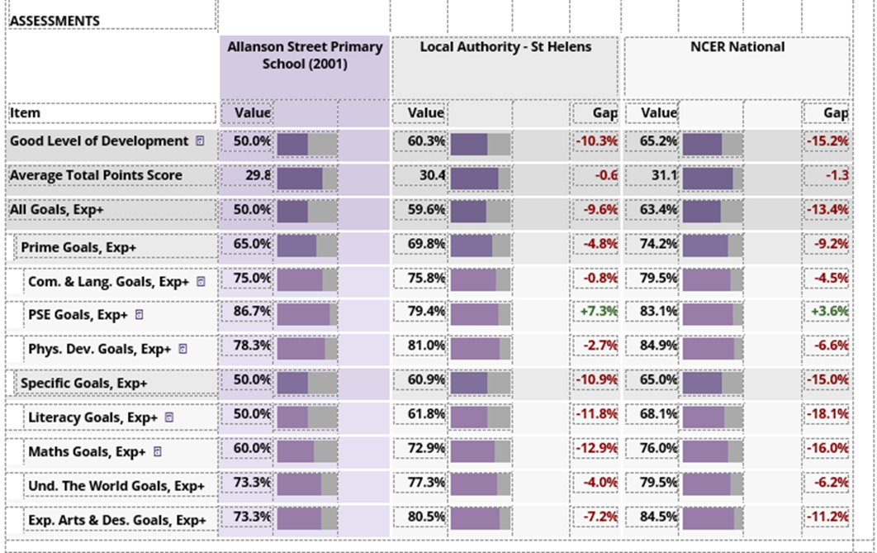
To add some context to this data, 35% of our Reception children are classified as disadvantaged, almost double the number of children in the LA (18.7%) and over 3 times the national average of 10.3%.
Whilst this data is a little disappointing, it is worth noting that many children in this cohort will have been impacted by Covid 19 in that they will not have been able to access nursery provision and toddler groups with the same regularity that they may otherwise have done. There is also the possibility that these children will have been affected by the strains that many families will have felt both emotionally and financially over the last two years.
However, some positives to take from this data set are the much higher percentages achieved in the prime areas (65% overall) with similar numbers of our children achieving these ELG’s compared to children in the LA and nationally. We know that many of our children join us with poor communication and language skills. Therefore, the fact that 75% of our children leave Reception having achieved the communication and language goal is a real success and a huge achievement both for the children and staff.
Another success is the fact that we have a higher than national average number of children who have achieved the personal, social and emotional goal (86.7% v 83.1%). The work that has gone into ensuring this high level of attainment should pay dividends in Year 1 and beyond as the children are better able to self-regulate and thus maintain a good mind state for learning.
End of KS1 Outcomes 2022
When scrutinising data for the past academic year, consideration of the context of this cohort is once again essential. A key point in this data set is the high percentage of PP children (50%), almost twice that of children of the same age in the LA and more than 3 times the national average.
Similarly, the number of SEN children (21.7% including EHCP) is 5% higher than similar aged cohorts in the LA and almost 7.2 % higher than similar aged cohorts nationally.
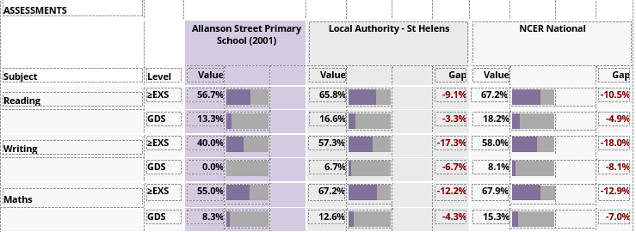

Unfortunately, these figures have dipped from the 2019 outcomes and remain below local and national averages.

Disadvantaged pupils continue to perform less well across reading, writing and mathematics with particularly significant gaps in reading and mathematics. Boys continue to perform less well in reading and writing but outperform girls in mathematics by 24%.

Continuing to improve KS1 attainment outcomes is a focus area for staff across EYFS and KS1: ensuring that children who meet the early learning goal at the end of EYFS meet the expected standard at the end of KS1 and that a greater percentage of those emerging at the end of EYFS convert this to the expected standard at the end of KS1.
Despite the impact of Covid in the last 2 years and the higher than average numbers of disadvantaged and SEND children in the cohort, we maintain the highest expectations and aspirations for our children and, as such, the highest quality teaching, intense intervention, focused work on attendance and strategies to boost parental engagement will all continue to be implemented for these children in Year 3 and beyond.

End of KS2 Outcomes 2022
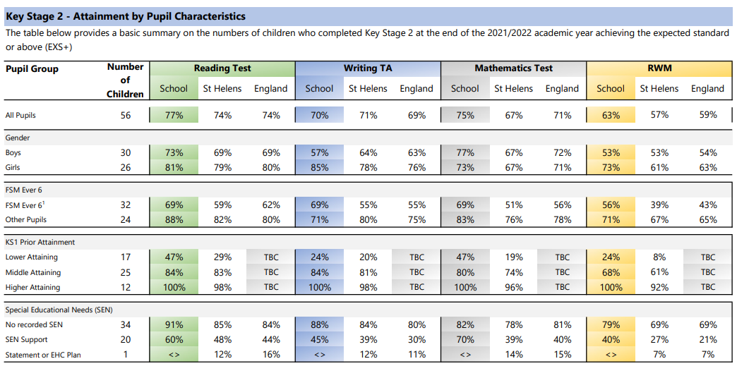

Gaps in the attainment of disadvantaged pupils compared to ’other’ pupils were broadly in line with national averages in reading, narrower in maths and significantly narrower in writing.
Narrowing any disadvantaged attainment gaps remains a priority.
2022 progress results improved across the board: reading (2.21), writing (0.96) and mathematics (1.79). This means that, on average, this cohort made greater progress at KS2 than those with similar prior attainment nationally.
In comparison to 2019 data, progress results for disadvantaged pupils in 2022 also improved for reading (0.68) and mathematics (1.04) but dipped for writing (0.68). Data shows that girls made better progress than boys in reading (2.36 compared to 2.09) and writing (1.82 compared to 0.26) but boys made significantly better progress than girls in mathematics (3.10 compared to 0.06).

Whilst attainment in reading, writing and maths, and RWM combined, was in line or slightly above national average at the end of Key Stage 2, it is clear from our EYFS and Key Stage 1 data that we still have a considerable way to go in terms of raising standards in English and maths across the school. We have clear action plans in place and feel confident that the strategies and initiatives that have already been introduced in the autumn term will have a positive impact on outcomes in 22/23.

Currently, although many of our children continue to have significant gaps in their learning, exploration of individual data sets show good progress is being made.
Children are developing secure knowledge, understanding and skills. Lesson observations, book scrutiny and school tracking data show that pupils develop secure knowledge and understanding and that attainment and progress is at least good for the vast majority of pupils from their different starting points. Year group action plans and whole school trackers provide a year on year analysis of progress and attainment for reading, writing and mathematics.

Unfortunately, we continue to see significant gaps between the attainment of our disadvantaged and non- disadvantaged children across school in reading, writing and maths. We also continue to see significant gaps between boys and girls in reading and writing. However, boys outperform girls in maths in all year groups with the exception of Year 1.

Recovery and School Led funding was fully utilised in 20/21 to provide individual and small group tutoring for children in Years 3 – 6. This was undertaken by in-house staff as well as tutors from our tuition partner, Tutor Trust.

An effective self-evaluation strategy is in place and effective monitoring procedures ensure that identified priorities lead to new initiatives and improved provision: the introduction of Read Write Inc and Fresh Start together with the purchase of ISHA, Wellcomm, Reading Plus and Tutor Trust programmes were all direct outcomes of monitoring and self-evaluation.

A focus on good attendance also remains a significant area for further improvement. Attendance figures for Autumn term 2022 show that we are already slightly below national average. As such, we are ensuring that no stone is left unturned in the drive to improve attendance.
During the past academic year, we have carefully mapped out a wide range of trips and activities designed to promote wider life experiences and develop pupils’ cultural capital. All children, from Nursery upwards now receive a free annual experience which is designed to enhance their understanding of our newly redesigned curriculum and their future aspirations. Whole school/key stage experiences have also been planned which aim to support our pupils understanding of the world.
Within school, our pupils now have access to an extensive range of free extra- curricular activities which take place at lunchtime and after school to ensure that no pupil is unable to attend and that they are all able to select something they would like to do throughout the school year. The activities provided focus specifically on harnessing pupils skills, interests and aspirations for later life.
As the cost of living crisis tightens its grip on our most disadvantaged families we continue to provide a comprehensive package of support for our children. This includes access to our free Rise and Shine breakfast club to ensure all children have a warm and nutritious start to the day, free uniform provision via our unicycle programme, free homework kits, access to our school food bank and a family club for those with children below Nursery age to access high quality pre-school provision for a fraction of the cost they would pay in the community. Our pastoral team also continue to support our most socially and emotionally vulnerable children and families offering specialist support and signposting to outside specialists where necessary, including our own designated school mental health specialist. Recent feedback from parents has indicated that many feel their children, and families as a whole, are very well supported by school and that staff care deeply about the children and their welfare. As a result, many of our disadvantaged families feel confident to ask for support if/when it is needed.
We will continue to build on all of the approaches outlined above and refocus on key priority areas to drive forward the progress, attainment and well- being of all of our pupils, especially those who experience significant disadvantage.

Externally provided programmes
Please include the names of any non-DfE programmes that you purchased in the previous academic year. This will help the Department for Education identify which ones are popular in England
Programme | Provider

Service pupil premium funding (optional)
For schools that receive this funding, you may wish to provide the following information:
Measure | Details
How did you spend your service pupil premium allocation last academic year?
What was the impact of that spending on service pupil premium eligible pupils?

Further information (optional)
Use this space to provide any further information about your pupil premium strategy. For example, about your strategy planning, or other activity that you are implementing to support disadvantaged pupils, that is not dependent on pupil premium or recovery premium funding.

