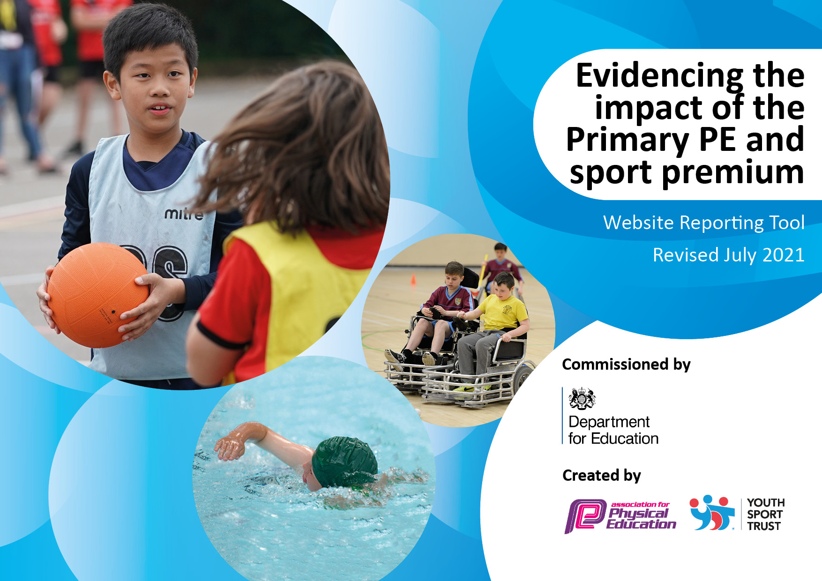
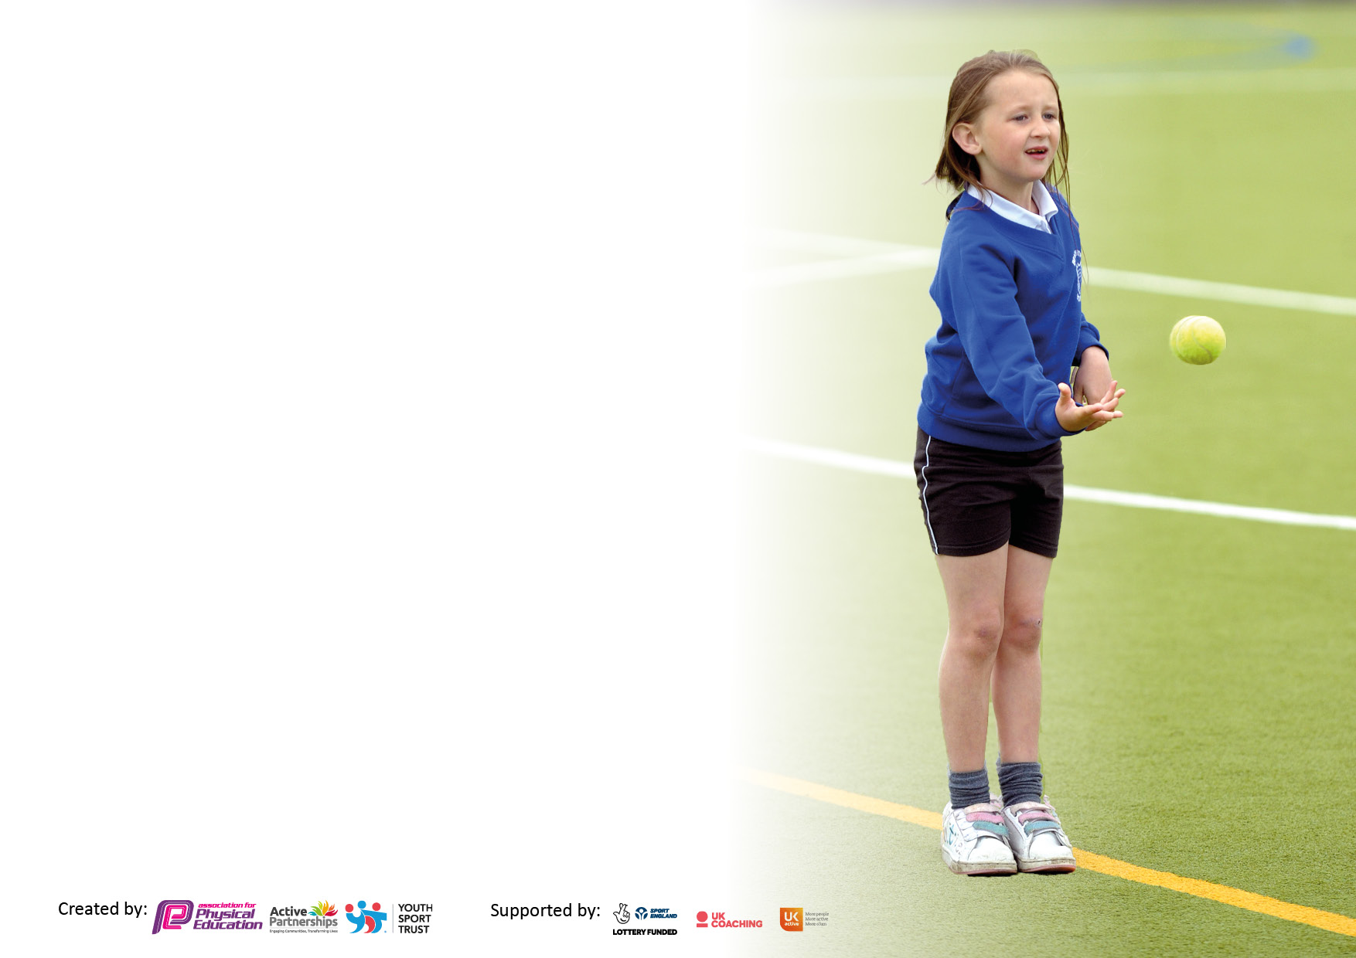

2021/22 FORMAT TO BE USED UNTIL 2022/23 FORMAT IS RELEASED BY THE ASSOCIATION FOR PHYSICAL EDUCATION.
It is important that your grant is used effectively and based on school need. The Education Inspection Framework makes clear there will be a focus on ‘whether leaders and those responsible for governors all understand their respective roles and perform these in a way that enhances the effectiveness of the school’.

Under the Quality of Education Ofsted inspectors consider:
Intent - Curriculum design, coverage and appropriateness
Implementation - Curriculum delivery, Teaching (pedagogy) and Assessment
Impact - Attainment and progress

To assist schools with common transferable language this template has been developed to utilise the same three headings which should make your plans easily transferable between working documents.

Schools must use the funding to make additional and sustainable improvements to the quality of Physical Education, School Sport and Physical Activity (PESSPA) they offer. This means that you should use the Primary PE and sport premium to:

- Develop or add to the PESSPA activities that your school already offer
- Build capacity and capability within the school to ensure that improvements made now will benefit pupils joining the school in future years
- The Primary PE and sport premium should not be used to fund capital spend projects; the school’s budget should fund these.
Please visit gov.uk for the revised DfE guidance including the 5 key indicators across which schools should demonstrate an improvement. This document will help you to review your provision and to report your spend. DfE encourages schools to use this template as an effective way of meeting the reporting requirements of the Primary PE and sport premium.
We recommend you start by reflecting on the impact of current provision and reviewing the previous spend.
Schools are required to publish details of how they spend this funding, including any under-spend from 2019/2020, as well as on the impact it has on pupils’ PE and sport participation and attainment. All funding must be spent by 31st July 2023.
We recommend regularly updating the table and publishing it on your website throughout the year. This evidences your ongoing self-evaluation of how you are using the funding to secure maximum, sustainable impact. Final copy must be posted on your website by the end of the academic year and no later than the 31st July 2023. To see an example of how to complete the table please click HERE.

Details with regard to funding
Please complete the table below.

Total amount carried over from 2021/22 | £0
Total amount allocated for 2021/22 | £19,473
How much (if any) do you intend to carry over from this total fund into 2022/23? | £0
Total amount allocated for 2022/23 | £19,550
Total amount of funding for 2022/23. To be spent and reported on by 31st July 2023. | £19,550
Swimming Data
Please report on your Swimming Data below.

Meeting national curriculum requirements for swimming and water safety | Swimming lessons take place at Newton Le Willows Health and Fitness Centre. This incurs high transport costs (not taken from sports premium). Year’s 4, 5 and 6 attend swimming sessions for one full term. This range of year groups should ensure that by the time children reach Year 6 they have received a full school year worth of swimming lessons. This will potentially increase children’s chances of passing the National Curriculum requirements for water and safety.  60%  73%  92%
What percentage of your current Year 6 cohort swim competently, confidently and proficiently over a distance of at least 25 metres?
N.B. Even though your pupils may swim in another year please report on their attainment on leaving primary school at the end of the summer term 2022.
Please see note above
What percentage of your current Year 6 cohort use a range of strokes effectively [for example, front crawl, backstroke and breaststroke]?
Please see note above
What percentage of your current Year 6 cohort perform safe self-rescue in different water-based situations?
Schools can choose to use the Primary PE and sport premium to provide additional provision for swimming but this must be for activity over and above the national curriculum requirements. Have you used it in this way? | Yes/No

Action Plan and Budget Tracking
Capture your intended annual spend against the 5 key indicators. Clarify the success criteria and evidence of impact that you intend to measure to evaluate for pupils today and for the future.

Academic Year: 2022/23 | Total fund allocated:£ | Date Updated: December 2022
Key indicator 1: The engagement of all pupils in regular physical activity – Chief Medical Officers guidelines recommend that primary school pupils undertake at least 30 minutes of physical activity a day in school |  |  |  | Percentage of total allocation:
 |  |  |  | 0%
Intent | Implementation |  | Impact to date
Your school focus should be clear what you want the pupils to know and be able to do and about  what they need to learn and to  consolidate through practice: | Make sure your actions to achieve are linked to your intentions: | Funding allocated: | Evidence of impact: what do pupils now know and what can they now do? What has changed? | Sustainability and suggested next steps:
To give children opportunities to get active during long teaching sessions.  The engagement of all pupils in regular physical activity – kickstarting healthy active lifestyles. | Allanson Street teachers to have access to ‘GoNoodle’, which provides short brain breaks for children to be active in the classroom. PE Lead to send resources from ‘Active Learning’ and any other resources found to enable children to be active during longer lessons.  Adults to organise games and activities at breaktime/lunchtime to encourage KS1 children to be active during these breaks. | £0  £0 | This provides children with opportunities to explore their fundamental skills during playtime for those children who do not enjoy the running games such as tig. A wide range of equipment provided ensuresall abilities and interests are catered for. Adult input provides the catalyst and ideas to encourage reluctant children to take part in physical activity. | Continue to provide children with the opportunity to be active during longer lessons and provide further resources so the activities do not become repetitive for the children.  Pupil, staff voice surveys to be carried out to help analysis.  PE Lead to source different resources.  Provide current Y6’s with training in leading games and activities by PE lead and sports apprentice.  Ensure middays are provided with training to ensure they can lead active sessions confidently.  Audit of playtime equipment to take place in Spring 1 to ensure variety and suitability.
Key indicator 2: The profile of PESSPA being raised across the school as a tool for whole school improvement |  |  |  | Percentage of total allocation:
 |  |  |  | 4%
Intent | Implementation |  | Impact to date
Your school focus should be clear what you want the pupils to know and be able to do and about  what they need to learn and to  consolidate through practice: | Make sure your actions to achieve are linked to your intentions: | Funding allocated: | Evidence of impact: what do pupils now know and what can they now do? What has changed? | Sustainability and suggested next steps:
To raise aspirations in sport throughout the school.  Celebration of achievement. Ensure the whole school is aware of the importance of PE within school.  Audit of PE equipment and provide new and engaging resources to ensure highest quality provision for all children.  Pupil voice – PE lead and sports coach to consult with children about the sports that they would like to participate in for extra-curricular activities.  Children to understand the importance of PE and Sport in a whole world context.  All children to recognise the importance of leading a lifelong healthy, active lifestyle.  Improved role modelling of healthy active lifestyle behaviours by all school staff to reach all children. | School visits from professional sportsmen/women to give talks to the children. Preferably from professionals from the local area to allow children to recognise that they can be successful in sport, regardless of the area in which they live in. (Jack Hunter-Spivey, Saints players etc.) Children to be encouraged to speak to aspirational people through ‘steps to success’ programme in school. PE lead to promote sportsmen/women.  Re-establish ‘Coach’s Sportsperson of the Week’ during Friday’s celebration assembly. Sports Apprentice and/or Class Teachers to recognise 2 children they have taught this week who have stood out to them during their PE lessons. (Once achievement assemblies recommence)  Achievements celebrated in assembly, match results etc. Out of school and after school sport celebrated via school newsletter.  Keep PE display board up to date with recent achievements of children in competitions and sport outside of school.  Dojo posts to celebrate participation in sports competitions.  Work towards sustaining Platinum School Games Activemark. This will need to be reapplied for in 2023/24  A range of new resources provided to engage and inspire the participation of PE.  Children will have more say in what sports takes place in school.  Activities to be planned around the different sporting events in the coming year.  Fit4Kids health and fitness workshop planned to be carried out this academic year  PE subject focus: “To encourage children to lead a lifelong healthy, active lifestyle.”  Staff to encourage children to choose healthy meal options. Staff to award Dojo’s for healthy choices/snacks.  Staff in the dining room to encourage children to try new foods or choose the healthy option and why this will benefit them. | £0  £0  £654.60 | The Tonga Rugby League Team came to visit at the start of the Rugby League World Cup. A question and answer session with Year 5 and 6 was undertaken.  Hearing how these players started off playing tag rugby like them and hearing how hard they worked to get to where they are now raised aspirations of the children.  Public acknowledgement and praise in assemblies along with dojo and newsletter posts have worked very well to raise the profile of school sports.  Children are bringing in sports trophies won outside of school to share in school celebration assemblies. This instils pride in the children. It raises awareness of the activities that children could be a part of and raises the profile of sports and physical activity within the school.  High quality resources have allowed a wide range of sports to be offered to all children.  Staff, parents and pupil voice surveys to be carried out termly and analysed to evidence this. Club registers show high attendance in all sporting clubs.  Arts week was linked to the Rugby League world cup. This allowed children to link their learning to a major sports tournament, raising the profile of sports, and show them that sport is worldwide.  Children are displaying a better understanding of how to lead a healthier lifestyle.  Through these sessions, children have also shown a desire to have healthier lunches.  Children visit the salad bar and choose healthy options to enhance their healthy dinner choices. The variety available encourages children to try new foods. | Forge positive relationships with various professional sports clubs around St. Helens/Merseyside to ensure this takes place in 22/23.  Ensure this continues and monitor impact.  Pupil voice to be carried out termly to evidence impact. Monitoring of numbers and variety of children putting themselves forward for inter school tournaments.  Annual review of resources.  Regular review of questionnaires from children.  PE lead to map out major tournaments and share on dojo or ensure ‘Steps to success’ reflects this  Organise Fit4Kids.  PE lead to approach ASDA/Morrisons to discuss their healthy eating sessions that are carried out in school for KS! And EYFS.

Key indicator 3: Increased confidence, knowledge and skills of all staff in teaching PE and sport |  |  |  | Percentage of total allocation:
 |  |  |  | 82%
Intent | Implementation |  | Impact to date
Your school focus should be clear | Make sure your actions to | Funding | Evidence of impact: what do | Sustainability and suggested
what you want the pupils to know | achieve are linked to your | allocated: | pupils now know and what | next steps:
and be able to do and about | intentions: |  | can they now do? What has
what they need to learn and to |  |  | changed?
consolidate through practice:
Improved quality of children's PE across the school to ensure all teachers are competent and confident in the delivery of PE.  To provide quality coaching delivered by professionals.  Improved swimming skills of children in year groups 5&6 (No Swimming in St Helens since Autumn term 2019) | Hiring of sports specialists to work alongside teachers and teaching assistants in a CPD role, during the delivery of class PE. PE specialists employed – Lucy for Dance, sports coach for other areas of PE.  Additional access to termly CPD in PE via Merseyside School Games Partnership. (Disney football for girls KS1 CPD)  PE subject leader to plan and undertake a series of lesson observations and/or team teaching with teachers to look at teaching, learning and assessment in physical education.  PE lead to have 12 hours allocated time to focus on the improvement of PE across school.  Work in partnership with Lancashire Cricket to provide high quality cricket coaching sessions for Y4 and 5. Teachers to attend these sessions with their class to gain ideas for future cricket PE lessons.  Ensure all teachers in KS2 are trained in delivery of swimming teaching | Sports coach - £15,000  Dance £7300  Costumes £150  £0 | All classes are now taking part in at least one PE lesson under guidance of sports specialists. Teachers have worked alongside specialists to team teach during PE lessons. Staff meeting discussion has shown that teachers feel more confidence in delivering their own PE as a result.  Constructive lesson observation feedback given to teachers from PE lead which has led to further improvements in teaching and learning.  Units of work shared on staff share which means those sessions delivered without specialist support are also high quality. The  Power of PE SOW available for all years.  Children have engaged in high quality cricket sessions. Raised aspirations of children to join professional cricket clubs.  Staff have completed swimming courses provided by St. Helen’s council, to ensure children receive high quality swimming lessons.  Children have returned to swimming sessions and have developed skills with a particular focus on life saving and rescue – see swimming data. | Continue with hiring of specialists.  PE lead to send any CPD opportunities to staff.  PE lead to arrange dates in new calendar of staff meetings.  To maintain links with local sports providers.  Keep in regular contact with St. Helens School Games.  Continue positive relationship with LC and accept future invitations for their sessions.  Any new members of staff to be sent on training.  To increase confidence look into refresher training for staff who completed training over 6 years
Key indicator 4: Broader experience of a range of sports and activities offered to all pupils |  |  |  | Percentage of total allocation:
 |  |  |  | 4%
Intent | Implementation |  | Impact to date
Your school focus should be clear | Make sure your actions to | Funding | Evidence of impact: what do | Sustainability and suggested
what you want the pupils to know | achieve are linked to your | allocated: | pupils now know and what | next steps:
and be able to do and about | intentions: |  | can they now do? What has
what they need to learn and to |  |  | changed?
consolidate through practice:
Introduce more KS1 and lower KS2 clubs. Sports coaches to broaden the sports they cover. | Focus on inclusive activities. Allow children to have a voice in extra-curricular clubs the school offers. Pupil voice to be sent round to classes prior to Spring 1 regarding after-school clubs.  Participate in St. Helen’s School Games inclusive activities/competitions, which are focused more on the inclusive activities than the traditional competitive sports. | £0 | Autumn term tournaments (10) were mainly for KS2 (availability through SHSG) however spring term tournaments include more year groups. Currently signed up to 13 tournaments in spring 1 covering the aspire, inspire and celebrate categories of competition and all year groups are included. | Continue to provide sporting clubs specifically aimed at KS1 and SEND children.

Key indicator 5: Increased participation in competitive sport |  |  |  | Percentage of total allocation:
 |  |  |  | 13%
Intent | Implementation |  | Impact to date
Your school focus should be clear | Make sure your actions to | Funding | Evidence of impact: what do | Sustainability and suggested
what you want the pupils to know | achieve are linked to your | allocated: | pupils now know and what | next steps:
and be able to do and about | intentions: |  | can they now do? What has
what they need to learn and to |  |  | changed?
consolidate through practice:
Develop teams to enter a wide variety of LV2 events and qualify for LV3.  To compete in St. Helens school games competitions, with a chance of qualifying for Merseyside school games competitions.  Enhanced provision package organised through SHAPES and SGO’s.  Remove some barriers which prevent some children from attending competitive sports.  Access to sports clubs outside of school. | Ensure all year groups are represented to attain maximum participation  PE coach to be released to help run the competitions (lunchtimes and regular PE slots to be used).  Enter all SSP School Games events and promote through website & ClassDojo.  Use of the mini-buses to transport pupils to competitive events and sporting activities.  Gifted & talented children to be identified by teachers and sports coach and encouraged to join a local sports club. Close links to be set up with local sports clubs and contact details for these clubs easily accessible. | SHAPES premium membership  £950  £2500 | A wide range of tournaments and competitions have been entered by children in Years 1 – 6.  Children are increasing their belief in themselves as sportsmen / women and believing in their abilities to compete.  Children are also broadening their knowledge of sporting opportunities and the different ways to be successful in sports.  Children are engaging in out of school clubs. This is increasing their fitness, raising aspirations and also improving links between home and school. | School will sign up for enhanced local school games package next year.  Continue to utilise the services of PECO Schools Network provider in the organisation and attendance of competitions.

Signed off by
Head Teacher: | L. Dingsdale
Date: | 11/12/22
Subject Leader: | C Spofforth
Date: | 08/12/22
Governor: | A Lashley
Date:

